MD Task 1a
Domain | Measurement and Data
Cluster | Measure and estimate lengths in standard units
Standard(s) | 2.MD.1 Measure the length of an object by selecting and using appropriate tools such as rulers, yardsticks, meter sticks, and measuring tapes.
Materials | String measuring 8 inches in length, ruler, yardstick, meter stick, measuring tape
Task | Show the student the materials. Say: I have a piece of string. What tool do you think we should use to measure the length of the string?  After the student selects a tool ask: Why did you choose that tool?  After the student provides and explanation, say: Use your tool to measure how long the string is. How long is the string?

Continuum of Understanding
Developing Understanding | - Does not select a ruler.  - Selects a ruler but doesn’t provide a reasonable explanation.  - Inaccurately measures the length of the string.
Complete Understanding | - Selects a ruler.  - Explanation includes an understanding that the string is a relatively short object and a ruler is an appropriate tool for shorter measurements (may state that all of the tools could be used to measure the string).  - Measures the length of the string accurately, aligning the starting point of the ruler with the end of the string.  - States that the string is 8 inches in length.

Standards for Mathematical Practice
1. Makes sense and perseveres in solving problems.
2. Reasons abstractly and quantitatively.
3. Constructs viable arguments and critiques the reasoning of others.
4. Models with mathematics.
5. Uses appropriate tools strategically.
6. Attends to precision.
7. Looks for and makes use of structure.
8. Looks for and expresses regularity in repeated reasoning.

MD Task 1b
Domain | Measurement and Data
Cluster | Measure and estimate lengths in standard units
Standard(s) | 2.MD.1 Measure the length of an object by selecting and using appropriate tools such as rulers, yardsticks, meter sticks, and measuring tapes.
Materials | pencil
Task | Say, Maria wants to measure the length of the hallway outside of her classroom. She has a ruler and a yardstick. Which tool do you think she should use? Explain your reasoning.

Continuum of Understanding
Developing Understanding | - Incorrectly states that the ruler would be the more appropriate tool.  - Recognizes that a yardstick is longer than a ruler, but the explanation is weak or nonexistent.  - Does not recognize that the yardstick is longer than the ruler, but the justification indicates an understanding of the need for a longer tool for longer lengths/distances.
Complete Understanding | - States that the yardstick would be the more appropriate tool.  - Recognizes that a yardstick is longer than a ruler.  - Provides an explanation that clearly justifies the use of a yardstick for longer lengths/distances.

Standards for Mathematical Practice
1. Makes sense and perseveres in solving problems.
2. Reasons abstractly and quantitatively.
3. Constructs viable arguments and critiques the reasoning of others.
4. Models with mathematics.
5. Uses appropriate tools strategically.
6. Attends to precision.
7. Looks for and makes use of structure.
8. Looks for and expresses regularity in repeated reasoning.

MD Task 2a
Domain | Measurement and Data
Cluster | Measure and estimate lengths in standard units
Standard(s) | 2.MD.2 Measure the length of an object twice, using length units of different lengths for the two measurements; describe how the two measurements relate to the size of the unit chosen.
Materials | Book that measures less than 12 inches, pencil, ruler (centimeters), 12 large paperclips
Task | Provide materials to the student. Read the problem to the student: Measure the length (or width) of the book in centimeters. About how many centimeters is the book?  Now measure the book using these paperclips. About how many paperclips did you need do measure the length (or width) of the book?  Are your two measurements the same or different? Why do you think that you have two “repeat student answer (same/different)” measurements?  NOTE: Depending on the size of the book and the size of the paper clips used, the student may need to state measurement as “about 24 centimeters” or “about 8 paperclips”.

Continuum of Understanding
Developing Understanding | - Incorrectly measures one or both items.  - Provides justification that is weak or minimal.  - Provides justification, but does not indicate an understanding of why the measurement results were different.
Complete Understanding | - Accurately measures the book with both units of measure.  - Provides detailed justification that indicates an understanding that the smaller the unit of measure, the more that unit is needed (compensatory principle).

Standards for Mathematical Practice
1. Makes sense and perseveres in solving problems.
2. Reasons abstractly and quantitatively.
3. Constructs viable arguments and critiques the reasoning of others.
4. Models with mathematics.
5. Uses appropriate tools strategically.
6. Attends to precision.
7. Looks for and makes use of structure.
8. Looks for and expresses regularity in repeated reasoning.

MD Task 2b
Domain | Measurement and Data
Cluster | Measure and estimate lengths in standard units.
Standard(s) | 2.MD.2 Measure the length of an object twice, using length units of different lengths for the two measurements; describe how the two measurements relate to the size of the unit chosen.
Materials | none
Task | Molly measured the length of their class book and reported that it was “7”. Evan measured the length of the same class book and said that it was really “14”. The teacher said that they were both correct. Use words, numbers, and pictures to explain why the teacher said that both Molly and Evan were right.

Continuum of Understanding
Developing Understanding | - Justification does not indicate an understanding that different units of measure were used.
Complete Understanding | - Provides detailed justification that indicates an understanding that more smaller units of measure are needed to cover a given length than larger units of measure (compensatory principle).

Standards for Mathematical Practice
1. Makes sense and perseveres in solving problems.
2. Reasons abstractly and quantitatively.
3. Constructs viable arguments and critiques the reasoning of others.
4. Models with mathematics.
5. Uses appropriate tools strategically.
6. Attends to precision.
7. Looks for and makes use of structure.
8. Looks for and expresses regularity in repeated reasoning.

MD Task 3a
Domain | Measurement and Data
Cluster | Measure and estimate lengths in standard units.
Standard(s) | 2.MD.3 Estimate lengths using units of inches, feet, centimeters, and meters.  2.MD.4 Measure to determine how much longer one object is than another, expressing the length difference in terms of a standard length unit.
Materials | SF, pencil, centimeter ruler
Task | Provide materials to the student. Read the problem: How many centimeters do you think the length of pencil A is? Write your estimate. How many centimeters do you think the length of pencil B is? Write your estimate. Measure the length of pencil A and pencil B in centimeters. Which pencil is the longest? How many more centimeters does the short pencil need to be so that it is the same length as the long pencil?

Continuum of Understanding
Developing Understanding | - Measures one or both of the pencils incorrectly.  - Measures both pencils correctly, but incorrectly determines the difference between the lengths. | - Uses the ruler correctly, lining up the end of the pencil with the zero point on the ruler.  Solved “How Many More” by:  - Counting up  - Counting back  - Basic fact  - Doubles  - Other
Complete Understanding | - Measures both pencils correctly: Pencil A, 14 centimeters; Pencil B, 18 centimeters  - Determines the difference between the two lengths correctly: 4 centimeters.

Standards for Mathematical Practice
1. Makes sense and perseveres in solving problems.
2. Reasons abstractly and quantitatively.
3. Constructs viable arguments and critiques the reasoning of others.
4. Models with mathematics.
5. Uses appropriate tools strategically.
6. Attends to precision.
7. Looks for and makes use of structure.
8. Looks for and expresses regularity in repeated reasoning.

Pencil A:

What is your estimate? ________________

How many centimeters do you think the length is? ________________

I measured the pencil. It is ___________________ centimeters long.

Pencil B:

What is your estimate? ________________

How many centimeters do you think the length is? ________________

I measured the pencil. It is ___________________ centimeters long.

Which pencil is the longest? ____________________________

How many more centimeters does the short pencil need to be so that it is the same length as the long pencil? _____________________

Explain your reasoning:

MD Task 3b
Domain | Measurement and Data
Cluster | Measure and estimate lengths in standard units
Standard(s) | 2.MD.3 Estimate lengths using units of inches, feet, centimeters, and meters.  2.MD.4 Measure to determine how much longer one object is than another, expressing the length difference in terms of a standard length unit.
Materials | SF, Pencil, ruler
Task | Provide materials to the student. Say: Anthony the Ant took this path to get to food (point to path at top of page). How many inches do you think Anthony the Ant will need to crawl? Write your estimate.  Caleb the Caterpillar took this path to get to food (point to path at top of page). How many inches do you think Caleb the Caterpillar will need to crawl. Write your estimate.  Measure both paths with a ruler. How many inches did Anthony the Ant take? Write your measurement. How many inches did Caleb the Caterpillar take? Write your measurement.  How many more inches did Caleb the Caterpillar crawl than Anthony the Ant? Use numbers, pictures, or words to show your thinking.

Continuum of Understanding
Developing Understanding | - Makes estimates, but one or both are extreme (e.g., 30 inches for one path).  - Inaccurately measures one or both paths.  - Accurately measures both paths, but incorrectly determines how much longer one path is than another. | - Uses the ruler correctly, lining up the end of the path with the zero point on the ruler.  Solved “How Many More” by:  - Counting up  - Counting back  - Basic fact  - Other
Complete Understanding | - Estimates are reasonable.  - Accurately measures both paths.  - Correctly determines how much longer one path is than another.

Standards for Mathematical Practice
1. Makes sense and perseveres in solving problems.
2. Reasons abstractly and quantitatively.
3. Constructs viable arguments and critiques the reasoning of others.
4. Models with mathematics.
5. Uses appropriate tools strategically.
6. Attends to precision.
7. Looks for and makes use of structure.
8. Looks for and expresses regularity in repeated reasoning.

Anthony the Ant

My Estimate: ________________________ I measured: ________________________

Caleb the Caterpillar

My Estimate: ________________________ I measured: ________________________
How many more inches did Caleb the Caterpillar crawl than Anthony the Ant?
Use numbers, pictures, or words to show your thinking.

Caleb the Caterpillar crawled ___________ more inches than Anthony the Ant.

MD Task 4a
Domain | Measurement and Data  Operations and Algebraic Thinking
Cluster | Relate addition and subtraction to length.  Represent and solve problems involving addition & subtraction.
Standard(s) | 2.MD.5 Use addition and subtraction within 100 to solve word problems involving lengths that are given in the same units, e.g., by using drawings and equations with a symbol for the unknown number to represent the problem.  2.OA.1 Use addition and subtraction within 100 to solve one- and two-step word problems involving situations of adding to, taking from, putting together, taking apart, and comparing, with unknowns in all positions, e.g., by using drawings and equations with a symbol for the unknown number to represent the problem.  Add To-Start Unknown, One-step
Materials | SF, Cubes or counters, pencil
Task | Provide materials to the student. Read the problem to the student: The teacher measured some fabric for a quilt. Then, she measured 10 more feet of fabric. Now she had 45 feet of fabric. How many feet of fabric did the teacher measure before? Write an equation that represents this problem. Use a symbol for the unknown number. Solve the problem and use words, numbers or pictures to explain your reasoning.

Continuum of Understanding
Developing Understanding | - Incorrectly solves the problem.  - Relies on counting as primary strategy for solving problem.  - Equation is inaccurate.  - Explanation is lacking in detail or non-existent. | Strategy(ies) Used:  - Counting All  - Counting On  - Makes Tens  - 10 more/less  - Basic Facts  - Creates easier or known sums  - Doubles  - Doubles +/- 1, 2  - Other:
Complete Understanding | - Correctly solves the problem: 35 feet of fabric  - Successfully uses strategies such as making tens, 10 more than/less than, and basic facts.  - Equation is accurate (e.g., 10 + * = 45; 45 – 10 = *)  - Explanation is clear.

Standards for Mathematical Practice
1. Makes sense and perseveres in solving problems.
2. Reasons abstractly and quantitatively.
3. Constructs viable arguments and critiques the reasoning of others.
4. Models with mathematics.
5. Uses appropriate tools strategically.
6. Attends to precision.
7. Looks for and makes use of structure.
8. Looks for and expresses regularity in repeated reasoning.

The teacher measured some fabric for a quilt. Then, she measured 10 more feet of fabric. Now she had 45 feet of fabric. How many feet of fabric did the teacher measure before?
Write an equation that represents this problem. Use a symbol for the unknown number.
Solve the problem.
Use words, numbers or pictures to explain your reasoning.

__________________ feet

MD Task 4b
Domain | Measurement and Data  Operations and Algebraic Thinking
Cluster | Relate addition and subtraction to length.  Represent and solve problems involving addition & subtraction.
Standard(s) | 2.MD.5 Use addition and subtraction within 100 to solve word problems involving lengths that are given in the same units, e.g., by using drawings and equations with a symbol for the unknown number to represent the problem.  2.OA.1 Use addition and subtraction within 100 to solve one- and two-step word problems involving situations of adding to, taking from, putting together, taking apart, and comparing, with unknowns in all positions, e.g., by using drawings and equations with a symbol for the unknown number to represent the problem.  Take From-Start Unknown, One-step
Materials | SF, Cubes or counters, pencil
Task | Provide materials to the student. Read the problem to the student: Grace measured a piece of string for the nature walk. She thought that it was too long, so she cut off 36 inches. Then her string was 30 inches. How many inches was Grace’s string before she cut it? Write an equation that represents this problem. Use a symbol for the unknown number. Solve the problem and use words, numbers or pictures to explain your reasoning.

Continuum of Understanding
Developing Understanding | - Incorrectly solves the problem.  - Relies on counting as primary strategy for solving problem.  - Equation is inaccurate.  - Explanation is lacking in detail or non-existent. | Strategy(ies) Used:  - Counting All  - Counting On  - Makes Tens  - Basic Facts  - Creates easier or known sums  - Doubles  - Doubles +/- 1, 2  - Other:
Complete Understanding | - Correctly solves the problem: 66 inches  - Successfully uses strategies such as making tens, creates easier or known sums, and basic facts.  - Equation is accurate (e.g., * - 36 = 30; 30 + 36 = *)  - Explanation is clear.

Standards for Mathematical Practice
1. Makes sense and perseveres in solving problems.
2. Reasons abstractly and quantitatively.
3. Constructs viable arguments and critiques the reasoning of others.
4. Models with mathematics.
5. Uses appropriate tools strategically.
6. Attends to precision.
7. Looks for and makes use of structure.
8. Looks for and expresses regularity in repeated reasoning.

Grace measured a piece of string for the nature walk. She thought that it was too long, so she cut off 36 inches. Then her string was 30 inches. How many inches was Grace’s string before she cut it?

Write an equation that represents this problem. Use a symbol for the unknown number.
Solve the problem.
Use words, numbers or pictures to explain your reasoning.

__________________ inches

MD Task 4c
Domain | Measurement and Data  Operations and Algebraic Thinking
Cluster | Relate addition and subtraction to length.  Represent and solve problems involving addition & subtraction.
Standard(s) | 2.MD.5 Use addition and subtraction within 100 to solve word problems involving lengths that are given in the same units, e.g., by using drawings and equations with a symbol for the unknown number to represent the problem.  2.OA.1 Use addition and subtraction within 100 to solve one- and two-step word problems involving situations of adding to, taking from, putting together, taking apart, and comparing, with unknowns in all positions, e.g., by using drawings and equations with a symbol for the unknown number to represent the problem.  Compare- Smaller Unknown: More, One-step
Materials | SF, Cubes or counters, pencil
Task | Provide materials to the student. Read the problem to the student: On the playground, Grace threw the ball 3 more feet than Ella. Grace threw the ball 21 feet. How far did Ella throw the ball? Write an equation that represents this problem. Use a symbol for the unknown number. Solve the problem and use words, numbers or pictures to explain your reasoning.

Continuum of Understanding
Developing Understanding | - Incorrectly solves the problem.  - Relies on counting as primary strategy for solving problem.  - Equation is inaccurate.  - Explanation is lacking in detail or non-existent. | Strategy(ies) Used:  - Counting All  - Counting On  - Makes Tens  - Basic Facts  - Creates easier or known sums  - Doubles  - Doubles +/- 1, 2  - Other:
Complete Understanding | - Correctly solves the problem: 31 bracelets  - Successfully uses strategies such as making tens, creates easier or known sums, and basic facts.  - Equation is accurate (e.g., 21 + 3 = *)  - Explanation is clear.

Standards for Mathematical Practice
1. Makes sense and perseveres in solving problems.
2. Reasons abstractly and quantitatively.
3. Constructs viable arguments and critiques the reasoning of others.
4. Models with mathematics.
5. Uses appropriate tools strategically.
6. Attends to precision.
7. Looks for and makes use of structure.
8. Looks for and expresses regularity in repeated reasoning.

On the playground, Grace threw the ball 3 more feet than Ella. Grace threw the ball 21 feet. How far did Ella throw the ball?

Write an equation that represents this problem. Use a symbol for the unknown number.
Solve the problem.
Use words, numbers or pictures to explain your reasoning.

__________________ feet

MD Task 4d
Domain | Measurement and Data  Operations and Algebraic Thinking
Cluster | Relate addition and subtraction to length.  Represent and solve problems involving addition & subtraction.
Standard(s) | 2.MD.5 Use addition and subtraction within 100 to solve word problems involving lengths that are given in the same units, e.g., by using drawings and equations with a symbol for the unknown number to represent the problem.  2.OA.1 Use addition and subtraction within 100 to solve one- and two-step word problems involving situations of adding to, taking from, putting together, taking apart, and comparing, with unknowns in all positions, e.g., by using drawings and equations with a symbol for the unknown number to represent the problem.  Compare-Bigger Unknown: Fewer, One-step
Materials | SF, Cubes or counters, pencil
Task | Provide materials to the student. Read the problem to the student: Martina ran 9 fewer yards than Nicole. Nicole ran for 21 yards. How many yards did Martina run? Write an equation that represents this problem. Use a symbol for the unknown number. Solve the problem and use words, numbers or pictures to explain your reasoning.

Continuum of Understanding
Developing Understanding | - Incorrectly solves the problem.  - Relies on counting as primary strategy for solving problem.  - Equation is inaccurate.  - Explanation is lacking in detail or non-existent. | Strategy(ies) Used:  - Counting All  - Counting On  - Makes Tens  - Basic Facts  - Creates easier or known sums  - Doubles  - Doubles +/- 1, 2  - Other:
Complete Understanding | - Correctly solves the problem: 12 yards  - Successfully uses strategies such as making tens, creates easier or known sums, and basic facts.  - Equation is accurate (e.g., 21 + 9 = *)  - Explanation is clear.

Standards for Mathematical Practice
1. Makes sense and perseveres in solving problems.
2. Reasons abstractly and quantitatively.
3. Constructs viable arguments and critiques the reasoning of others.
4. Models with mathematics.
5. Uses appropriate tools strategically.
6. Attends to precision.
7. Looks for and makes use of structure.
8. Looks for and expresses regularity in repeated reasoning.

Martina ran 9 fewer yards than Nicole. Nicole ran for 21 yards. How many yards did Martina run?

Write an equation that represents this problem. Use a symbol for the unknown number.
Solve the problem.
Use words, numbers or pictures to explain your reasoning.

__________________ yards

MD Task 6a
Domain | Measurement and Data  Operations and Algebraic Thinking
Cluster | Relate addition and subtraction to length.  Represent and solve problems involving addition & subtraction.
Standard(s) | 2.MD.6 Represent whole numbers as lengths from 0 on a number line diagram with equally spaced points corresponding to the numbers 0,1,2,…, and represent whole-number sums and differences within 100 on a number line diagram.  2.OA.1 Use addition and subtraction within 100 to solve one- and two-step word problems involving situations of adding to, taking from, putting together, taking apart, and comparing, with unknowns in all positions, e.g., by using drawings and equations with a symbol for the unknown number to represent the problem.  Compare-Difference Unknown: More, One-step
Materials | SF, pencil
Task | Provide materials to the student. Read the problem to the student: The 2nd graders had a jumping contest. Mary jumped 38 inches. Sue jumped 55 inches. How much farther did Sue jump than Mary? Use a number line to solve. Use numbers and words to show your thinking.

Continuum of Understanding
Developing Understanding | - Attempts to draw a number line but is unable to represent spaces accurately.  - Solves the problem incorrectly.  - Draws the number line inaccurately.  - Justification is weak and/or does not accurately represent the strategy used on the number line. | Strategy(ies) Used:  - Makes Tens  - Creates easier or known sums  - Basic Facts  - Doubles  - Doubles +/- 1, 2  - Other:
Complete Understanding | - Correctly solves the problem: 17 inches  - Represents numbers as lengths on a number line with equally spaced points corresponding to necessary numbers.  - Uses the number line as a tool to solve the problem accurately.  - The justification is clear and accurately represents the strategy used on the number line.

Standards for Mathematical Practice
1. Makes sand perseveres in solving problems.
2. Reasons abstractly and quantitatively.
3. Constructs viable arguments and critiques the reasoning of others.
4. Models with mathematics.
5. Uses appropriate tools strategically.
6. Attends to precision.
7. Looks for and makes use of structure.
8. Looks for and expresses regularity in repeated reasoning.

The 2nd graders had a jumping contest. Mary jumped 38 inches. Sue jumped 55 inches. How much farther did Sue jump than Mary?

Use a number line to solve.
Use numbers and words to show your thinking.

__________________ inches

MD Task 6b
Domain | Measurement and Data  Operations and Algebraic Thinking
Cluster | Relate addition and subtraction to length.  Represent and solve problems involving addition & subtraction.
Standard(s) | 2.MD.6 Represent whole numbers as lengths from 0 on a number line diagram with equally spaced points corresponding to the numbers 0,1,2,…, and represent whole-number sums and differences within 100 on a number line diagram.  2.OA.1 Use addition and subtraction within 100 to solve one- and two-step word problems involving situations of adding to, taking from, putting together, taking apart, and comparing, with unknowns in all positions, e.g., by using drawings and equations with a symbol for the unknown number to represent the problem.  Add To-Result Unknown, One-step
Materials | SF, pencil
Task | Provide materials to the student. Read the problem to the student: Imani found 27 pinecones in the woods. Then she found 24 more pinecones. How many pinecones did Imani find? Use a number line to solve. Use numbers and words to show your thinking.

Continuum of Understanding
Developing Understanding | - Attempts to draw a number line but is unable to represent spaces accurately.  - Solves the problem incorrectly.  - Draws the number line inaccurately.  - Justification is weak and/or does not accurately represent the strategy used on the number line. | Strategy(ies) Used:  - Makes Tens  - Creates easier or known sums  - Basic Facts  - Doubles  - Doubles +/- 1, 2  - Other:
Complete Understanding | - Correctly solves the problem: 51 pinecones  - Represents numbers as lengths on a number line with equally spaced points corresponding to necessary numbers.  - Uses the number line as a tool to solve the problem accurately.  - The justification is clear and accurately represents the strategy used on the number line.

Standards for Mathematical Practice
1. Makes sand perseveres in solving problems.
2. Reasons abstractly and quantitatively.
3. Constructs viable arguments and critiques the reasoning of others.
4. Models with mathematics.
5. Uses appropriate tools strategically.
6. Attends to precision.
7. Looks for and makes use of structure.
8. Looks for and expresses regularity in repeated reasoning.

Imani found 27 pinecones in the woods. Then she found 24 more pinecones. How many pinecones did Imani find?

Use a number line to solve.
Use numbers and words to show your thinking.

__________________ pinecones

MD Task 6c
Domain | Measurement and Data  Operations and Algebraic Thinking
Cluster | Relate addition and subtraction to length.  Represent and solve problems involving addition & subtraction.
Standard(s) | 2.MD.6 Represent whole numbers as lengths from 0 on a number line diagram with equally spaced points corresponding to the numbers 0,1,2,…, and represent whole-number sums and differences within 100 on a number line diagram.  2.OA.1 Use addition and subtraction within 100 to solve one- and two-step word problems involving situations of adding to, taking from, putting together, taking apart, and comparing, with unknowns in all positions, e.g., by using drawings and equations with a symbol for the unknown number to represent the problem.  Take From-Result Unknown, One-step
Materials | SF, pencil
Task | Provide materials to the student. Read the problem to the student: Emmanuel poured 43 candies in the jar. His sister took 13 candies out of the jar. How many candies are now in the jar? Use a number line to solve. Use numbers and words to show your thinking.

Continuum of Understanding
Developing Understanding | - Attempts to draw a number line but is unable to represent spaces accurately.  - Solves the problem incorrectly.  - Draws the number line inaccurately.  - Justification is weak and/or does not accurately represent the strategy used on the number line. | Strategy(ies) Used:  - Makes Tens  - Creates easier or known sums  - Basic Facts  - Doubles  - Doubles +/- 1, 2  - Other:
Complete Understanding | - Correctly solves the problem: 30 candies  - Represents numbers as lengths on a number line with equally spaced points corresponding to necessary numbers.  - Uses the number line as a tool to solve the problem accurately.  - The justification is clear and accurately represents the strategy used on the number line.

Standards for Mathematical Practice
1. Makes sand perseveres in solving problems.
2. Reasons abstractly and quantitatively.
3. Constructs viable arguments and critiques the reasoning of others.
4. Models with mathematics.
5. Uses appropriate tools strategically.
6. Attends to precision.
7. Looks for and makes use of structure.
8. Looks for and expresses regularity in repeated reasoning.

Emmanuel poured 43 candies in the jar. His sister took 13 candies out of the jar. How many candies are now in the jar?

Use a number line to solve.
Use numbers and words to show your thinking.

__________________ candies

MD Task 7a
Domain | Measurement and Data
Cluster | Work with time and money
Standard(s) | 2.MD.7 Tell and write time from analog and digital clocks to the nearest five minutes, using a.m. and p.m.
Materials | BLM-clocks, small clock with movable hour and minute hands, pencil
Task | Read aloud each problem to the student and show each card as appropriate.  Task A: Ella’s class goes to lunch at this time (time shows 12:15 pm). What time does Ella’s class go to lunch? (twelve-fifteen) What is another way to say this same time? (quarter past 12). Show this time on your clock (student moves hands on clock to make the time).  Task C: Sam eats dinner at this time (clock shows 6:30). What time does Sam eat dinner? (six-thirty) What is another way to say this same time? (half-past six). Write this time on the digital clock. Be sure to also use a.m. or p.m. (6:30 p.m.).

Continuum of Understanding
Developing Understanding | - Incorrectly tells one or more times.  - Verbally tells the time in at least one way correctly, but not two.  - Reads one type of clock, but not the other.  - Indicates a.m./p.m. incorrectly. | - States the time for a digital clock.  - States the time for an analog clock.  - Writes the time.  - Moves hands to show the time.  - Uses a.m. and p.m. correctly.  Complete Understanding:  - quarter past  - half-past  - 30 minutes after/before  - o’clock
Complete Understanding | - Tells the time for both an analog and digital clock in two ways.  - Correctly writes the time for a digital clock.  - Correctly shows the time with an analog clock.

Standards for Mathematical Practice
1. Makes sense and perseveres in solving problems.
2. Reasons abstractly and quantitatively.
3. Constructs viable arguments and critiques the reasoning of others.
4. Models with mathematics.
5. Uses appropriate tools strategically.
6. Attends to precision.
7. Looks for and makes use of structure.
8. Looks for and expresses regularity in repeated reasoning.

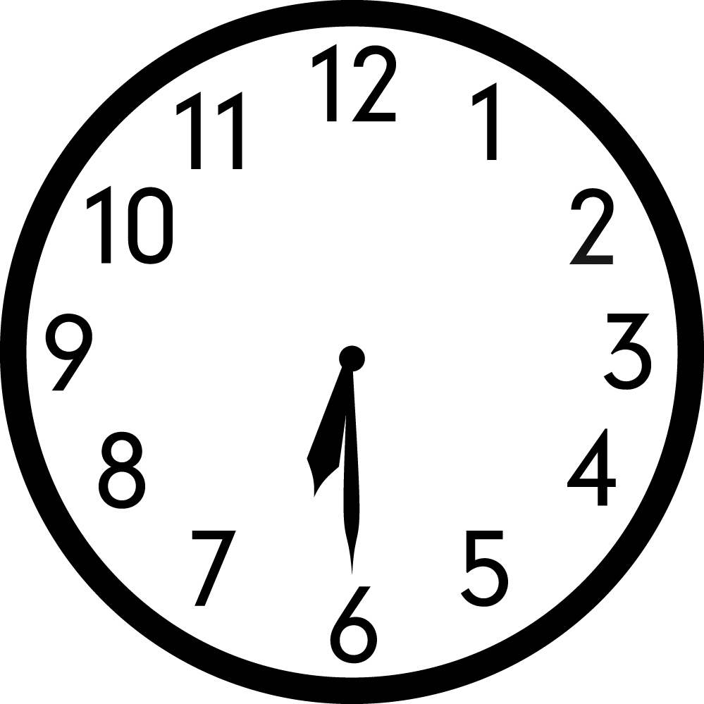

MD Task 7b
Domain | Measurement and Data
Cluster | Work with time and money
Standard(s) | 2.MD.7 Tell and write time from analog and digital clocks to the nearest five minutes, using a.m. and p.m.
Materials | SF, pencil
Task | Provide the materials to the student. Read the problem to the student: What time is shown on the clock? Write the time next to the clock. After the student has finished writing the time, read the next part of the problem to the student: What time is shown on the clock? Draw the hands to show the time of the clock.

Continuum of Understanding
Developing Understanding | - Incorrectly tells one or more times.  - Reads one type of clock, but not the other.
Complete Understanding | - Tells the time for both an analog and digital clock correctly.  - Correctly writes the time for a digital clock.  - Correctly shows the time with an analog clock.

Standards for Mathematical Practice
1. Makes sense and perseveres in solving problems.
2. Reasons abstractly and quantitatively.
3. Constructs viable arguments and critiques the reasoning of others.
4. Models with mathematics.
5. Uses appropriate tools strategically.
6. Attends to precision.
7. Looks for and makes use of structure.
8. Looks for and expresses regularity in repeated reasoning.

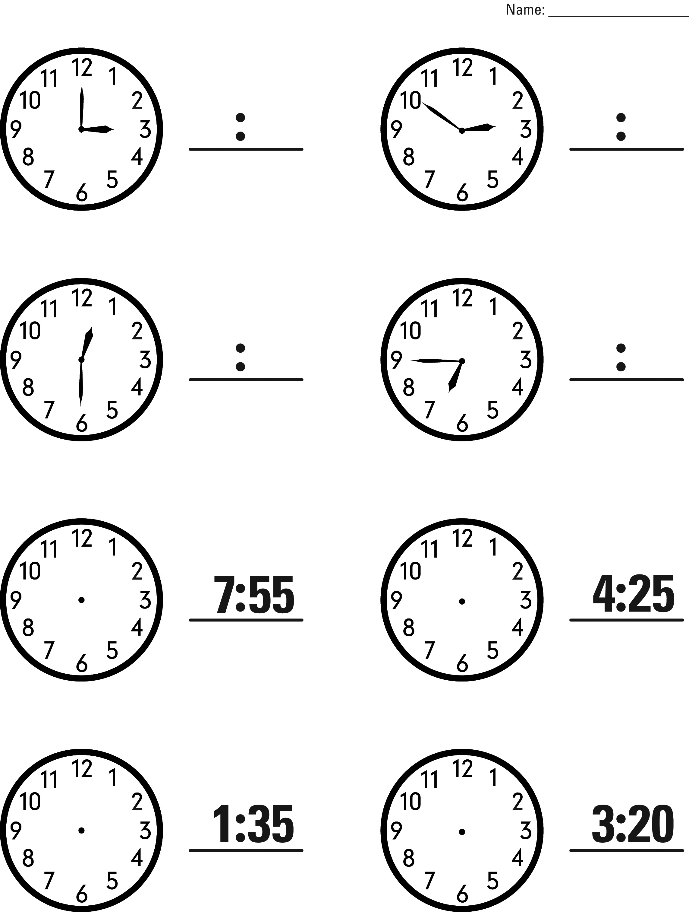

MD Task 8a
Domain | Measurement and Data  Operations and Algebraic Thinking  Number and Operations in Base Ten
Cluster | Work with time and money.  Represent and solve problems involving addition & subtraction.  Use place value understanding and properties of operations to add and subtract.
Standard(s) | 2.MD.8 Solve word problems involving dollar bills, quarters, dimes, nickels, and pennies, using $ and ¢ symbols appropriately.  2.OA.1 Use addition and subtraction within 100 to solve one- and two-step word problems involving situations of adding to, taking from, putting together, taking apart, and comparing, with unknowns in all positions, e.g., by using drawings and equations with a symbol for the unknown number to represent the problem.  2.NBT.6 Add up to four two-digit numbers using strategies based on place value and properties of operations.  Put Together/Take Apart-Addend Unknown, One-step
Materials | SF, pencil
Task | Provide the materials to the student. Read the problem to the student: Jordan found five coins at the bottom of his bookbag. Three are dimes and two are nickels. How much money did Jordan find? Explain your reasoning with numbers and words.

Continuum of Understanding
Developing Understanding | - Incorrectly identifies the value of a dime/nickel.  - Incorrectly solves the problem.  - Relies on counting as primary strategy for solving problem.  - Explanation is lacking in detail or non-existent. | Strategy(ies) Used:  - Counting All  - Counting On  - Makes Tens  - Basic Facts  - Creates easier or known sums  - Doubles  - Doubles +/- 1, 2  - Other:  Knows value of:  - Dime  - Nickel
Complete Understanding | - Correctly solves the problem: 40¢  - Successfully uses strategies such as making tens, creates easier or known sums, and basic facts.  - Explanation indicates understanding of the value of the coins and illustrates strategies used to solve the problem.

Standards for Mathematical Practice
1. Makes sense and perseveres in solving problems.
2. Reasons abstractly and quantitatively.
3. Constructs viable arguments and critiques the reasoning of others.
4. Models with mathematics.
5. Uses appropriate tools strategically.
6. Attends to precision.
7. Looks for and makes use of structure.
8. Looks for and expresses regularity in repeated reasoning.

Jordan found five coins at the bottom of his book bag. Three are dimes and two are nickels. How much money did Jordan find?

Explain your reasoning with numbers and words.

__________________ money

MD Task 8b
Domain | Measurement and Data  Operations and Algebraic Thinking
Cluster | Work with time and money.  Represent and solve problems involving addition & subtraction.
Standard(s) | 2.MD.8 Solve word problems involving dollar bills, quarters, dimes, nickels, and pennies, using $ and ¢ symbols appropriately.  2.OA.1 Use addition and subtraction within 100 to solve one- and two-step word problems involving situations of adding to, taking from, putting together, taking apart, and comparing, with unknowns in all positions, e.g., by using drawings and equations with a symbol for the unknown number to represent the problem.  Compare-Difference Unknown: More, One-step
Materials | SF, pencil
Task | Provide the materials to the student. Read the problem to the student: The First Grade classes raised $56 during the school fund raiser. The Second Grade classes raised $84 during the school fund raiser. How much more money did the Second Grade classes raise than the First Grade Classes? Write an equation that represents this problem. Use a symbol for the unknown number. Solve the problem and use words, numbers or pictures to explain your reasoning.

Continuum of Understanding
Developing Understanding | - Incorrectly solves the problem.  - Relies on counting as primary strategy for solving problem.  - Equation is inaccurate.  - Explanation is lacking in detail or non-existent. | Strategy(ies) Used:  - Counting All  - Counting On  - Makes Tens  - Basic Facts  - Creates easier or known sums  - Doubles  - Doubles +/- 1, 2  - Other:
Complete Understanding | - Correctly solves the problem: $28  - Successfully uses strategies such as making tens, creates easier or known sums, and basic facts.  - Equation is accurate (e.g., $84 = $56 + *; $84 - $56 = *).  - Explanation is clear.

Standards for Mathematical Practice
1. Makes sense and perseveres in solving problems.
2. Reasons abstractly and quantitatively.
3. Constructs viable arguments and critiques the reasoning of others.
4. Models with mathematics.
5. Uses appropriate tools strategically.
6. Attends to precision.
7. Looks for and makes use of structure.
8. Looks for and expresses regularity in repeated reasoning.

The First Grade classes raised $56 during the school fund raiser. The Second Grade classes raised $84 during the school fund raiser. How much more money did the Second Grade classes raise than the First Grade Classes?

Write an equation that represents this problem. Use a symbol for the unknown number.
Solve the problem.
Use words, numbers or pictures to explain your reasoning.

__________________ money

MD Task 8c
Domain | Measurement and Data  Operations and Algebraic Thinking  Number and Operations in Base Ten
Cluster | Work with time and money.  Represent and solve problems involving addition & subtraction.  Use place value understanding and properties of operations to add and subtract.
Standard(s) | 2.MD.8 Solve word problems involving dollar bills, quarters, dimes, nickels, and pennies, using $ and ¢ symbols appropriately.  2.OA.1 Use addition and subtraction within 100 to solve one- and two-step word problems involving situations of adding to, taking from, putting together, taking apart, and comparing, with unknowns in all positions, e.g., by using drawings and equations with a symbol for the unknown number to represent the problem.  2.NBT.6 Add up to four two-digit numbers using strategies based on place value and properties of operations.  Put Together/Take Apart- Addend Unknown, Two-step
Materials | SF, pencil
Task | Provide the materials to the student. Read the problem to the student: Tyler opened his piggy bank. He counted 67¢. He found two quarters, one dime, and some pennies. How many pennies did Tyler find? Explain your reasoning with numbers and words.

Continuum of Understanding
Developing Understanding | - Incorrectly identifies the value of one or more coins.  - Incorrectly solves the problem.  - Relies on counting as primary strategy for solving problem.  - Explanation is lacking in detail or non-existent. | Strategy(ies) Used:  - Counting All  - Counting On  - Makes Tens  - Basic Facts  - Creates easier or known sums  - Doubles  - Doubles +/- 1, 2  - Other:  Knows value of:  - Quarter  - Dime  - Penny
Complete Understanding | - Correctly solves the problem: 7 pennies or 7¢  - Successfully uses strategies such as making tens, creates easier or known sums, and basic facts.  - Explanation indicates understanding of the value of the coins and illustrates strategies used to solve the problem.

Standards for Mathematical Practice
1. Makes sense and perseveres in solving problems.
2. Reasons abstractly and quantitatively.
3. Constructs viable arguments and critiques the reasoning of others.
4. Models with mathematics.
5. Uses appropriate tools strategically.
6. Attends to precision.
7. Looks for and makes use of structure.
8. Looks for and expresses regularity in repeated reasoning.

Tyler opened his piggy bank. He counted 67¢. He found two quarters, one dime, and some pennies. How many pennies did Tyler find?

Explain your reasoning with numbers and words.

__________________ pennies

MD Task 8d
Domain | Measurement and Data  Operations and Algebraic Thinking  Number and Operations in Base Ten
Cluster | Work with time and money.  Represent and solve problems involving addition & subtraction.  Use place value understanding and properties of operations to add and subtract.
Standard(s) | 2.MD.8 Solve word problems involving dollar bills, quarters, dimes, nickels, and pennies, using $ and ¢ symbols appropriately.  2.OA.1 Use addition and subtraction within 100 to solve one- and two-step word problems involving situations of adding to, taking from, putting together, taking apart, and comparing, with unknowns in all positions, e.g., by using drawings and equations with a symbol for the unknown number to represent the problem.  2.NBT.6 Add up to four two-digit numbers using strategies based on place value and properties of operations.  Put Together/Take Apart-Total Unknown, Two-step
Materials | SF, pencil
Task | Provide the materials to the student. Read the problem to the student: Joel went to the store and bought three items. He bought a pencil for a dime, an eraser for 38¢, and a pencil sharpener for a quarter. How much money did Joel spend at the store? Explain your reasoning with numbers and words.

Continuum of Understanding
Developing Understanding | - Incorrectly identifies the value of a quarter and/or dime.  - Incorrectly solves the problem.  - Relies on counting as primary strategy for solving problem.  - Explanation is lacking in detail or non-existent. | Strategy(ies) Used:  - Counting All  - Counting On  - Makes Tens  - Basic Facts  - Creates easier or known sums  - Doubles  - Doubles +/- 1, 2  - Other:  Knows value of:  - Dime  - Quarter
Complete Understanding | - Correctly solves the problem: 73¢  - Successfully uses strategies such as making tens, creates easier or known sums, and basic facts.  - Explanation indicates understanding of the value of the coins and illustrates strategies used to solve the problem.

Standards for Mathematical Practice
1. Makes sense and perseveres in solving problems.
2. Reasons abstractly and quantitatively.
3. Constructs viable arguments and critiques the reasoning of others.
4. Models with mathematics.
5. Uses appropriate tools strategically.
6. Attends to precision.
7. Looks for and makes use of structure.
8. Looks for and expresses regularity in repeated reasoning.

Joel went to the store and bought three items. He bought a pencil for a dime, an eraser for 38¢, and a pencil sharpener for a quarter. How much money did Joel spend at the store?

Explain your reasoning with numbers and words.

__________________ pennies

MD Task 9a
Domain | Measurement and Data
Cluster | Represent and interpret data.
Standard(s) | 2.MD.9. Generate measurement data by measuring lengths of several objects to the nearest whole unit, or by making repeated measurements of the same object. Show the measurements by making a line plot, where the horizontal scale is marked off in whole-number units.
Materials | SF, pencil
Task | Provide the materials to the student. Read the problem to the student: Sarah measured a handful of ribbons to the nearest inch. She wrote down each ribbon’s measurement in a table. Make a line plot to represent the data.  After the student has created the line plot and transferred the data say: Look at your data. How many pieces of string did Sarah measure? Write your answer. How much longer in inches is the longest piece of string compared to the shortest piece of string? Write your answer.

Continuum of Understanding
Developing Understanding | - Incorrectly creates a line plot.  - Inaccurately transfers the data collected to a line plot.  - Answers one or both questions about the data incorrectly. | Solution:  4 X  3 X X  2 X X X  1 X X X X  1 inch 2 inches 3 inches 4 inches
Complete Understanding | - Correctly uses one “x” for each count, transferring the data to the line plot correctly.  - Correctly answers the questions: 10 pieces of string, 3 inches

Standards for Mathematical Practice
1. Makes sense and perseveres in solving problems.
2. Reasons abstractly and quantitatively.
3. Constructs viable arguments and critiques the reasoning of others.
4. Models with mathematics.
5. Uses appropriate tools strategically.
6. Attends to precision.
7. Looks for and makes use of structure.
8. Looks for and expresses regularity in repeated reasoning.

Sarah’s Ribbon Measurements
4 | 4 | 2 | 2 | 2 | 3 | 1 | 4 | 2 | 1
Sarah measured a handful of ribbons to the nearest inch. She wrote down each ribbon’s measurement in a table.

Make a line plot to represent the data.

Sarah’s Ribbon Measurements
4
3
2
1
 | 1 inch | 2 inches | 3 inches | 4 inches

How many pieces of string did Sarah measure? __________

How much longer is the longest piece of string compared to the shortest piece of string? ___________

MD Task 9b
Domain | Measurement and Data
Cluster | Represent and interpret data.
Standard(s) | 2.MD.9 Generate measurement data by measuring lengths of several objects to the nearest whole unit, or by making repeated measurements of the same object. Show the measurements by making a line plot, where the horizontal scale is marked off in whole-number units.
Materials | SF, ruler (inches), pencil
Task | Provide the materials to the student. Read the problem to the student: Use a ruler to measure the length of each pencil and write the measurement next to each pencil. Use the blank line plot to display your data. What do you notice about your data? Describe your data in at least 3 different ways.

Continuum of Understanding
Developing Understanding | - Measures one or more pencils inaccurately.  - Incorrectly creates a line plot.  - Inaccurately transfers the data collected to a line plot.  - Describes the data inaccurately or in only 1-2 different ways. | - Uses the ruler correctly, lining up the end of the pencil with the zero point on the ruler.  - The categories on the line plot are labeled.  - One “x” is used for each count on the line plot.  Pencil Measurement Solutions:  - 3 in. - 2 in.  - 6 in. - 4 in.  - 7 in. - 4 in.  - 3 in. - 8 in.  - 4 in. - 6 in.
Complete Understanding | - Measures each pencil correctly.  - Creates a line plot with categories that are labeled and uses one “x” for each count.  - Transfers the data to the line plot correctly.  - Describes the data accurately in at least 3 different ways (e.g., states amount for each category, notices similarities and differences between category counts, identifies total number of pencils measured, compares categories- more/less)

Standards for Mathematical Practice
1. Makes sense and perseveres in solving problems.
2. Reasons abstractly and quantitatively.
3. Constructs viable arguments and critiques the reasoning of others.
4. Models with mathematics.
5. Uses appropriate tools strategically.
6. Attends to precision.
7. Looks for and makes use of structure.
8. Looks for and expresses regularity in repeated reasoning.

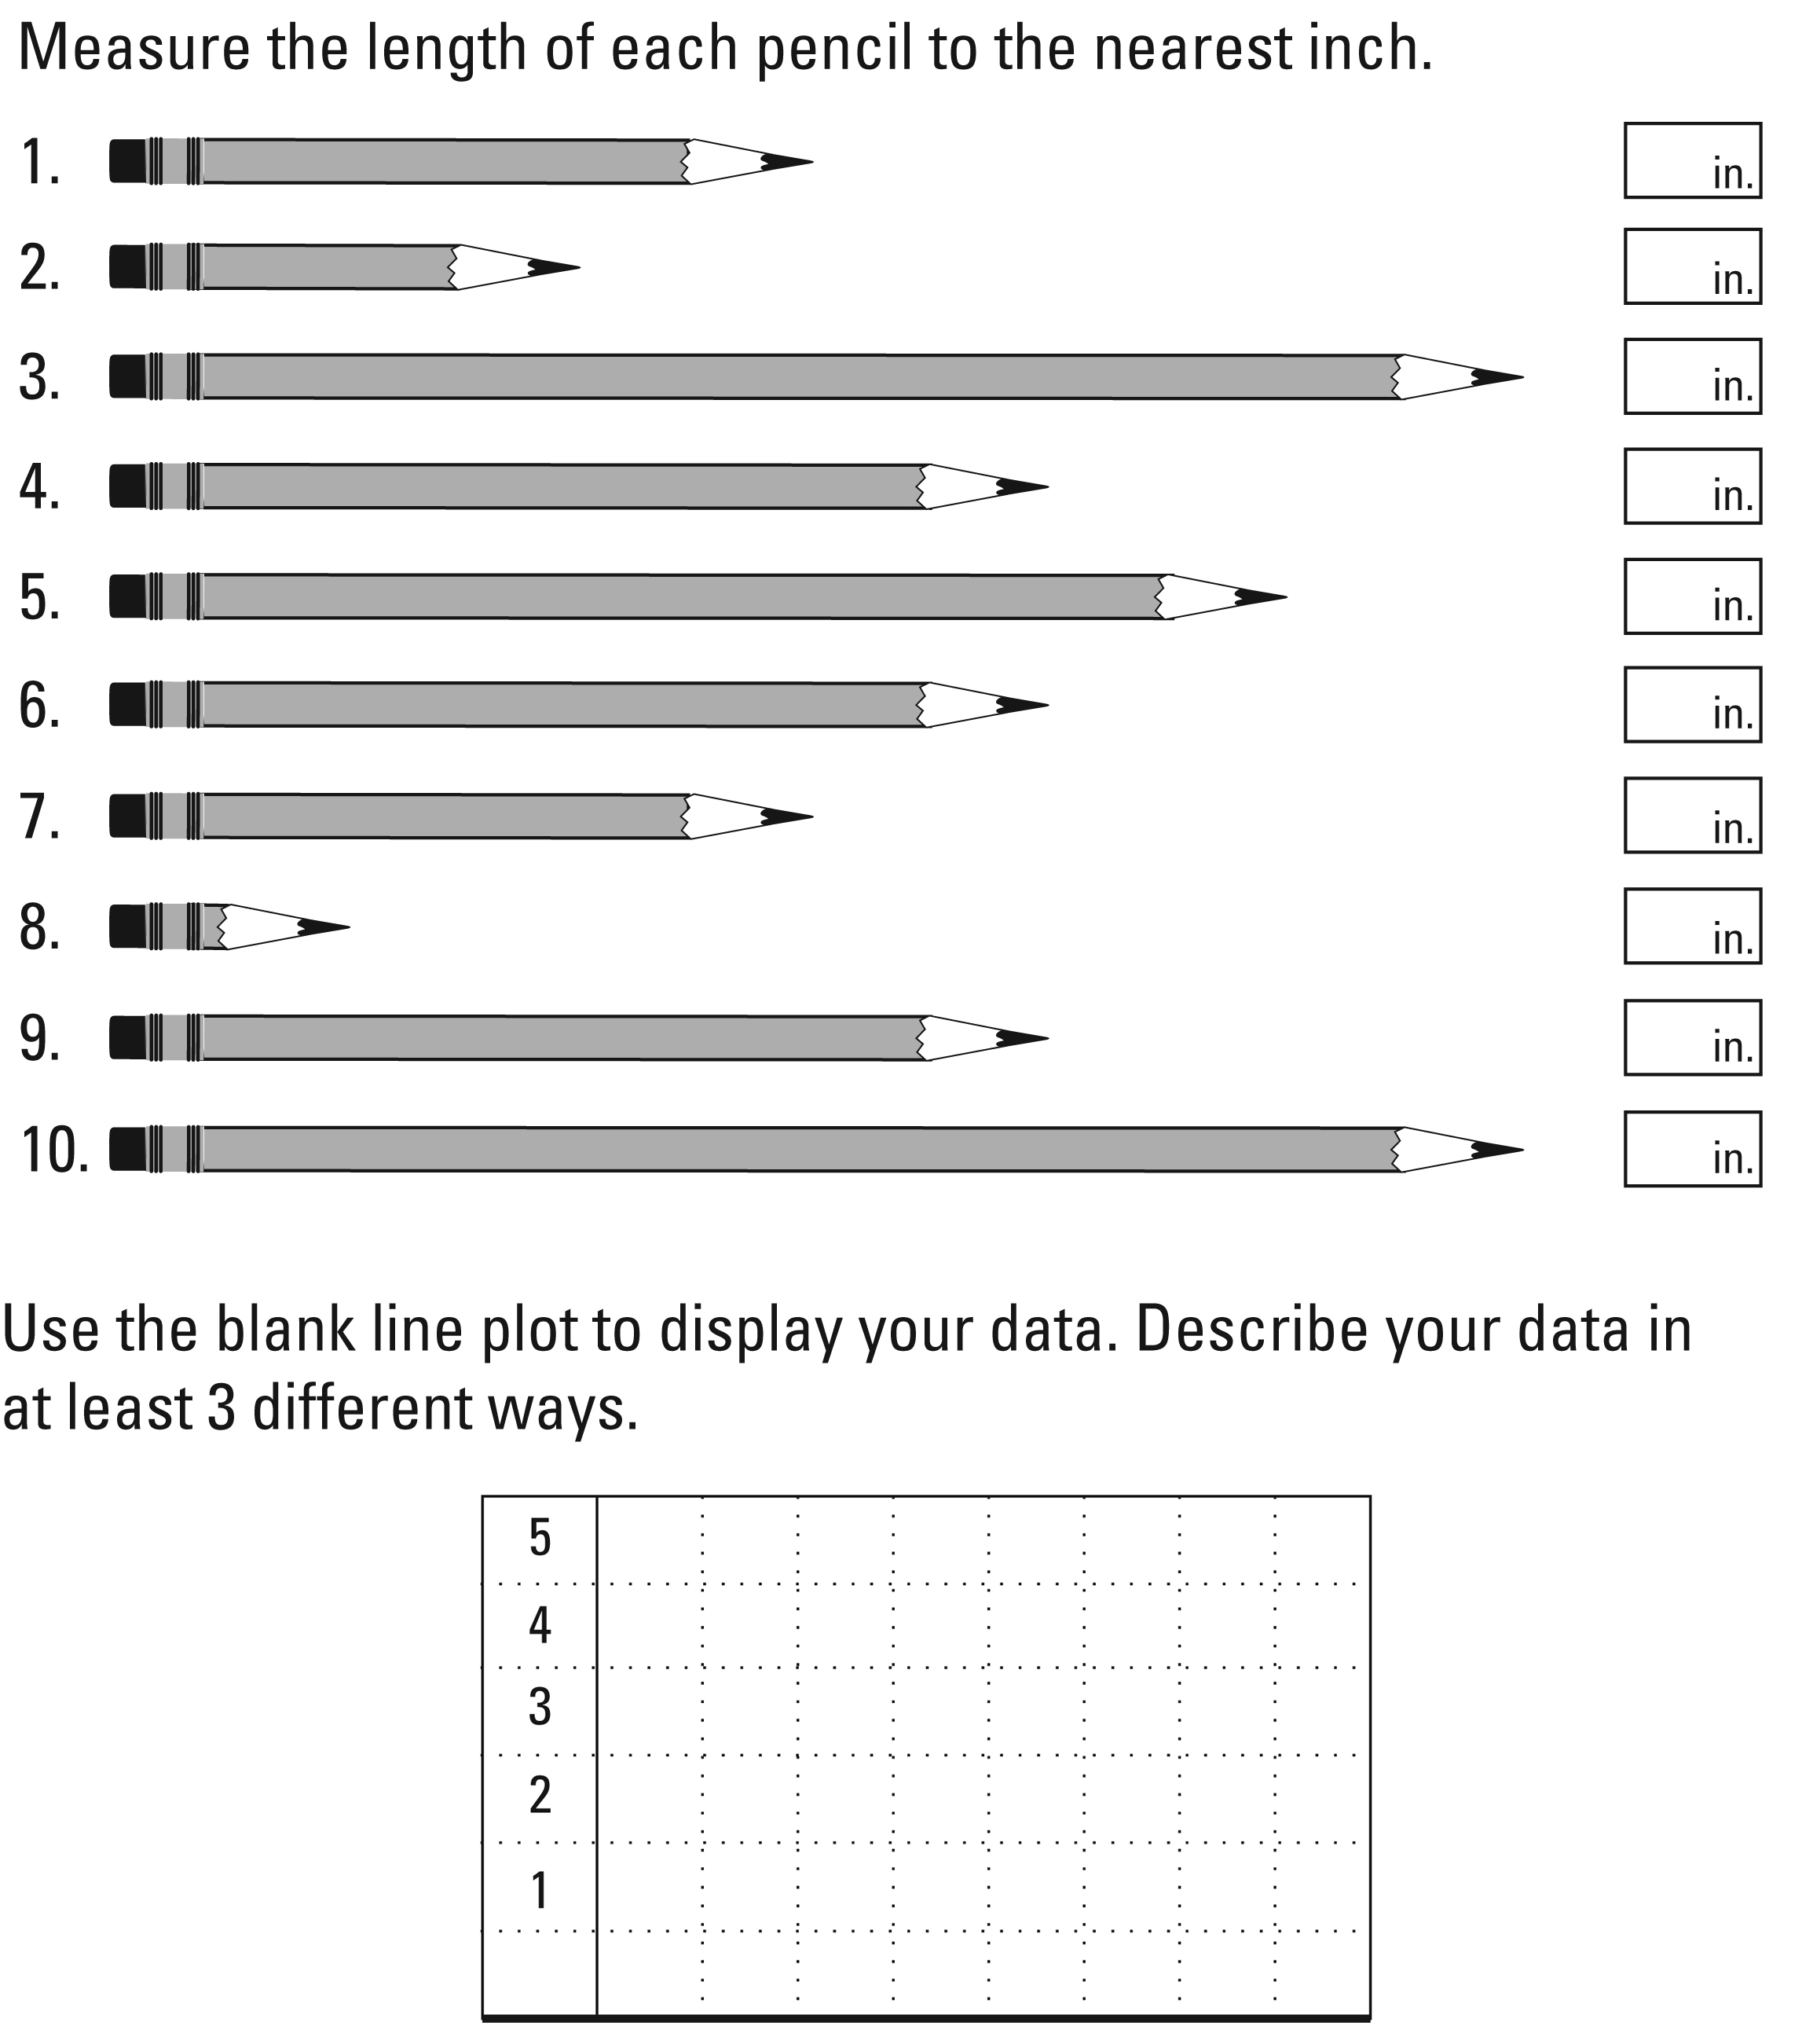

MD Task 9c
Domain | Measurement and Data
Cluster | Represent and interpret data.
Standard(s) | 2.MD.9 Generate measurement data by measuring lengths of several objects to the nearest whole unit, or by making repeated measurements of the same object. Show the measurements by making a line plot, where the horizontal scale is marked off in whole-number units.
Materials | SF, ruler (centimeter), pencil
Task | Provide the materials to the student. Read the problem to the student: Use a ruler to measure the length of each crayon to the nearest centimeter and write the measurement next to each crayon. Use the blank line plot to display your data. What do you notice about your data? Describe your data in at least 3 different ways.

Continuum of Understanding
Developing Understanding | - Measures one or more crayons inaccurately.  - Incorrectly creates a line plot.  - Inaccurately transfers the data collected to a line plot.  - Describes the data inaccurately or in only 1-2 different ways. | - Uses the ruler correctly, lining up the end of the pencil with the zero point on the ruler.  - The columns on the line plot are labeled sequentially.  - One “x” is used for each count on the line plot.  Crayon Measurement Solutions:  - 7 cm - 10 cm  - 9 cm - 8 cm  - 7 cm - 13 cm  - 8 cm - 7 cm  - 13 cm - 7 cm
Complete Understanding | - Measures each crayon correctly.  - Creates a line plot with columns that are labeled sequentially.  - Correctly uses one “x” for each count.  - Transfers the data to the line plot correctly.  - Describes the data accurately in at least 3 different ways (e.g., states amount for each category, notices similarities and differences between category counts, identifies total number of pencils measured, compares categories- more/less)

Standards for Mathematical Practice
1. Makes sense and perseveres in solving problems.
2. Reasons abstractly and quantitatively.
3. Constructs viable arguments and critiques the reasoning of others.
4. Models with mathematics.
5. Uses appropriate tools strategically.
6. Attends to precision.
7. Looks for and makes use of structure.
8. Looks for and expresses regularity in repeated reasoning.

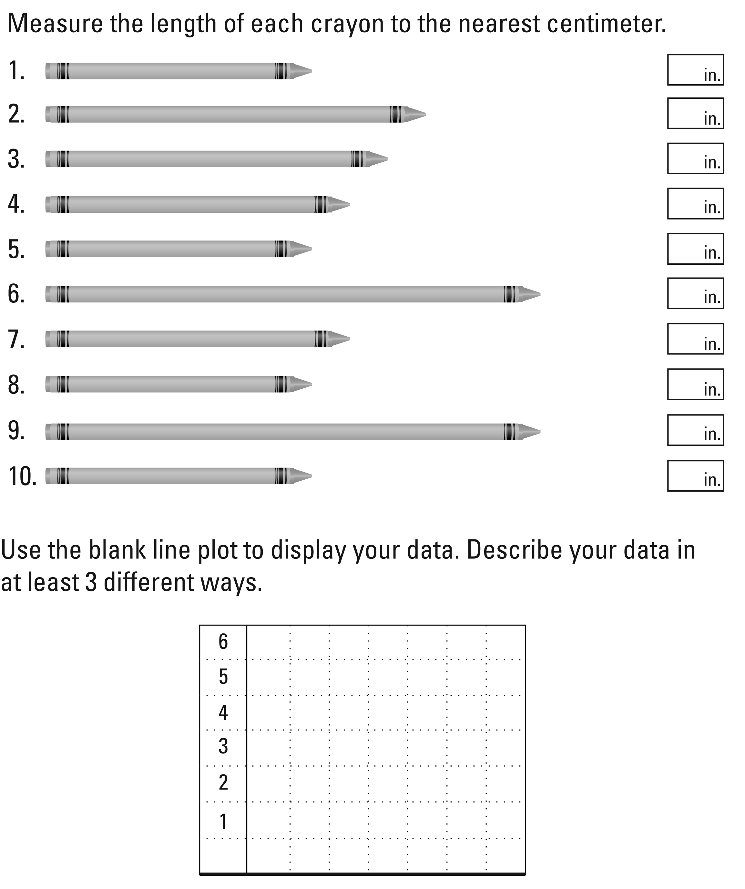

MD Task 10a
Domain | Measurement and Data
Cluster | Represent and interpret data.
Standard(s) | 2.MD.10 Draw a picture graph and a bar graph (with single-unit scale) to represent a data set with up to four categories. Solve simple put-together, take-apart, and compare problems using information presented in a bar graph.
Materials | SF, pencil
Task | Provide the materials to the student. Read the problem to the student: Juan measured a handful of markers to the nearest inch. He wrote down each marker’s measurement in a table. Make a bar graph to represent the data.  After the student has created the bar graph and transferred the data say: Look at your data. How many markers did Juan measure? Then say: Describe your data in at least 2 different ways.

Continuum of Understanding
Developing Understanding | - Incorrectly creates a bar graph.  - Inaccurately transfers the data collected to a bar graph.  - Determines the total number of markers as an amount other than 10.  - Description of data is minimal or incorrect.
Complete Understanding | - Correctly transfers the data to the bar graph correctly.  - Correctly answers the question: 10 pencils  - Describes the data in at least 2 different ways (e.g., states amount for each category, notices similarities and differences between category counts, compares categories- more/less)

Standards for Mathematical Practice
1. Makes sense and perseveres in solving problems.
2. Reasons abstractly and quantitatively.
3. Constructs viable arguments and critiques the reasoning of others.
4. Models with mathematics.
5. Uses appropriate tools strategically.
6. Attends to precision.
7. Looks for and makes use of structure.
8. Looks for and expresses regularity in repeated reasoning.

Juan’s Marker Measurements
9 | 5 | 6 | 8 | 9 | 6 | 8 | 8 | 8 | 8
Juan measured a handful of markers to the nearest inch. He wrote down each marker’s measurement in a table.

Make a bar graph to represent the data.
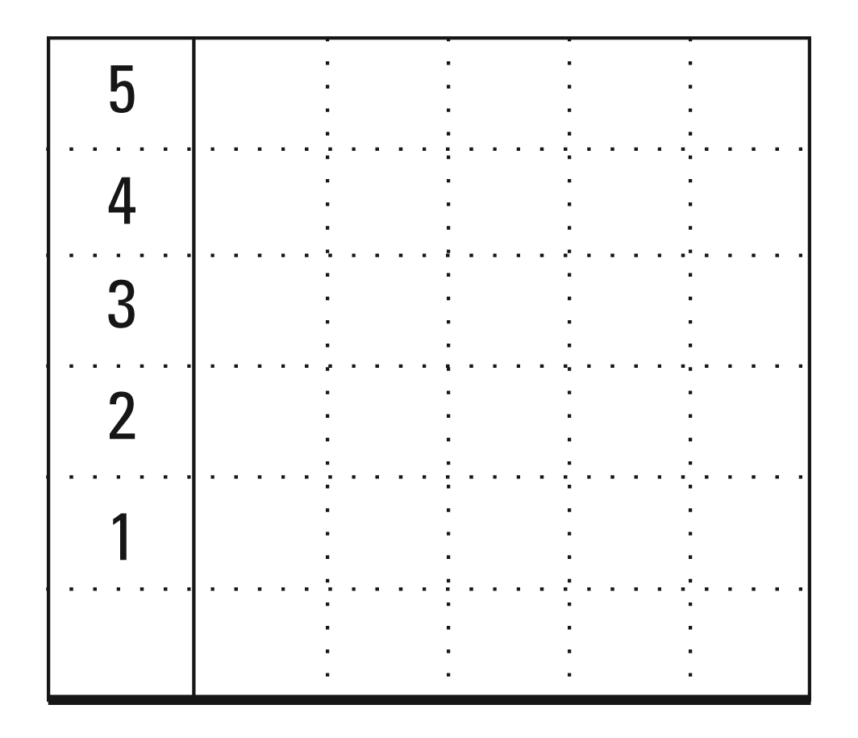

How many markers did Juan measure? _________________

Describe your data in at least 2 different ways.

MD Task 10b
Domain | Measurement and Data
Cluster | Represent and interpret data.
Standard(s) | 2.MD.10 Draw a picture graph and a bar graph (with single-unit scale) to represent a data set with up to four categories. Solve simple put-together, take-apart, and compare problems using information presented in a bar graph.
Materials | SF, pencil
Task | Provide materials to the student. Read the problem to the student: Look at the table below. Mr. Miller’s class made a survey of their favorite pizza topping. Use the data from the survey to create a bar graph. How many students are in the class? Which pizza topping is the most favorite? Which pizza topping is the least favorite? How many more students like pepperoni than mushroom?  The students from Mr. Miller’s class used the survey to help order pizza for lunch. The pizza shop was out of sausage. So, the students who liked sausage decided to get pepperoni instead. How many students had pepperoni on their pizza?

Continuum of Understanding
Developing Understanding | - Transfers the survey data to a bar graph.  - Incorrectly labels the bar graph.  - Answers one or more questions incorrectly. | Solutions:  - 24 students in class.  - Cheese is most favorite.  - Sausage is least favorite.  - 6 more students like pepperoni than mushroom.  - 11 students had pepperoni.
Complete Understanding | - Represents all survey information on a bar graph.  - Creates a title and labels each category of the bar graph.  - Answers each question about the data correctly.

Standards for Mathematical Practice
1. Makes sense and perseveres in solving problems.
2. Reasons abstractly and quantitatively.
3. Constructs viable arguments and critiques the reasoning of others.
4. Models with mathematics.
5. Uses appropriate tools strategically.
6. Attends to precision.
7. Looks for and makes use of structure.
8. Looks for and expresses regularity in repeated reasoning.

Mr. Miller’s class used a survey to find out everyone’s favorite pizza topping. They put their results in a table.

Cheese | 10
Pepperoni | 9
Sausage | 2
Mushroom | 3

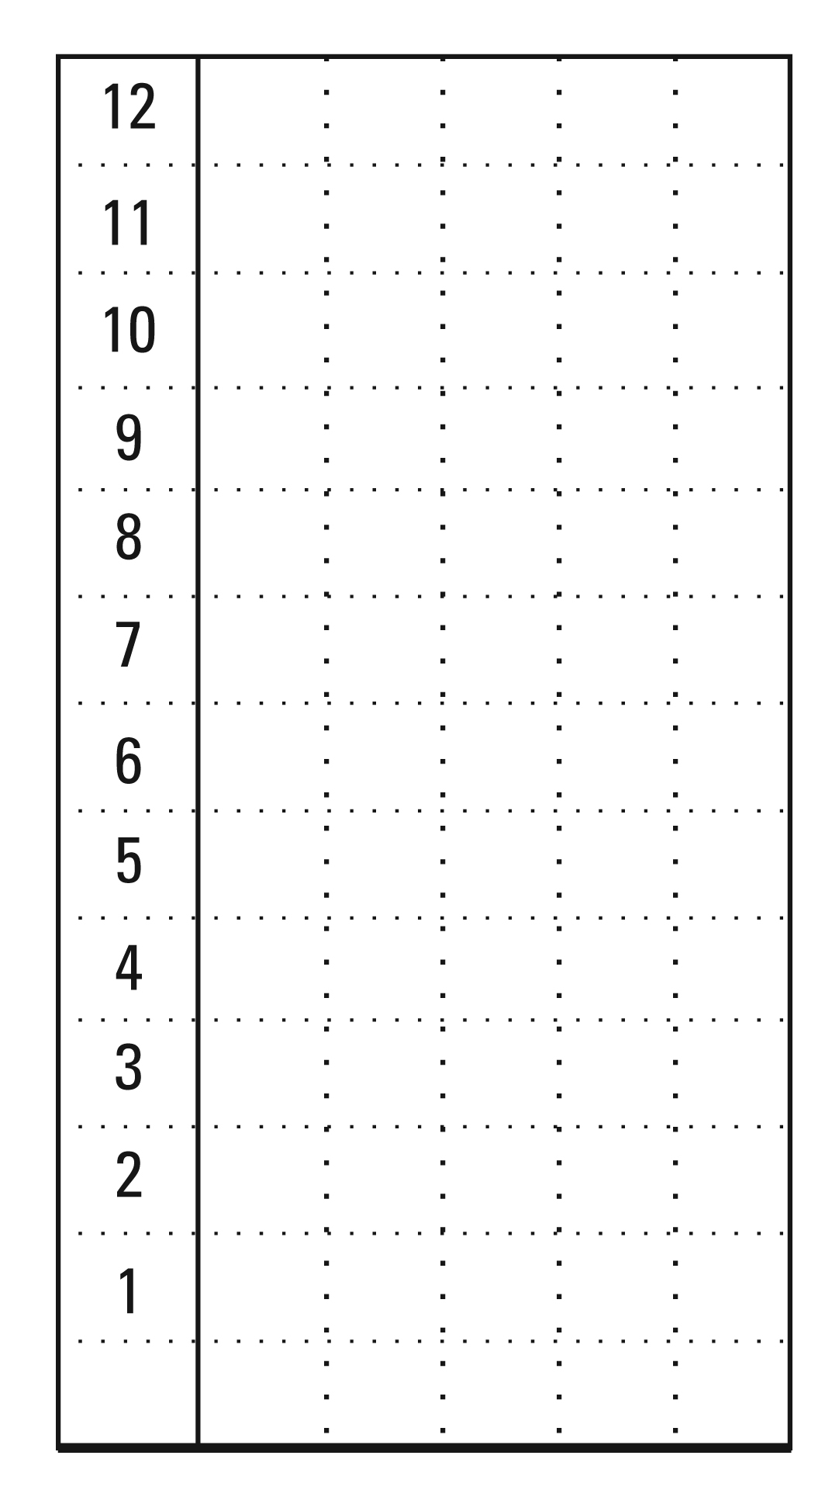
Use the data from the survey to create a bar graph below.

Use the data to answer the questions.

How many students are in the class? _______
Which pizza topping is the most favorite? ___________________
Which pizza topping is the least favorite? ___________________
How many more students like pepperoni than mushroom? _____________

The students from Mr. Miller’s class used the survey to help order pizza for lunch. The pizza shop was out of sausage. So, the students who liked sausage decided to order pepperoni instead. How many students ordered pepperoni pizza?

Justify your reasoning.

________ students ordered pepperoni pizza

