G Task 1a
Domain | Geometry
Cluster | Reason with shapes and their attributes.
Standard(s) | 2.G.1 Recognize and draw shapes having specified attributes, such as a given number of angles or a given number of equal faces. Identify triangles quadrilaterals, pentagons, hexagons, and cubes.  *Sizes are compared directly or visually, not compared by measuring.
Materials | SF, pencil
Task | Provide the student with the materials. Read the directions: Circle all of the quadrilaterals. Explain how you know that the shapes you circled are quadrilaterals.

Continuum of Understanding
Developing Understanding | - Identifies some of the quadrilaterals, but not all.  - Uses non-defining attributes in the justification (e.g., size, color) | Answer:  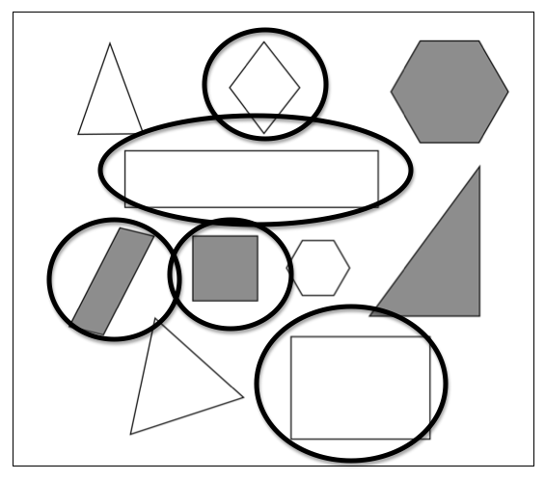  Identifies types of quadrilaterals:  - square  - rectangle  - trapezoid
Complete Understanding | - Identifies all of the quadrilaterals.  - Uses defining attributes to justify why each shape is a quadrilateral (sides, angles)

Standards for Mathematical Practice
1. Makes sense and perseveres in solving problems.
2. Reasons abstractly and quantitatively.
3. Constructs viable arguments and critiques the reasoning of others.
4. Models with mathematics.
5. Uses appropriate tools strategically.
6. Attends to precision.
7. Looks for and makes use of structure.
8. Looks for and expresses regularity in repeated reasoning.

Circle all of the quadrilaterals.

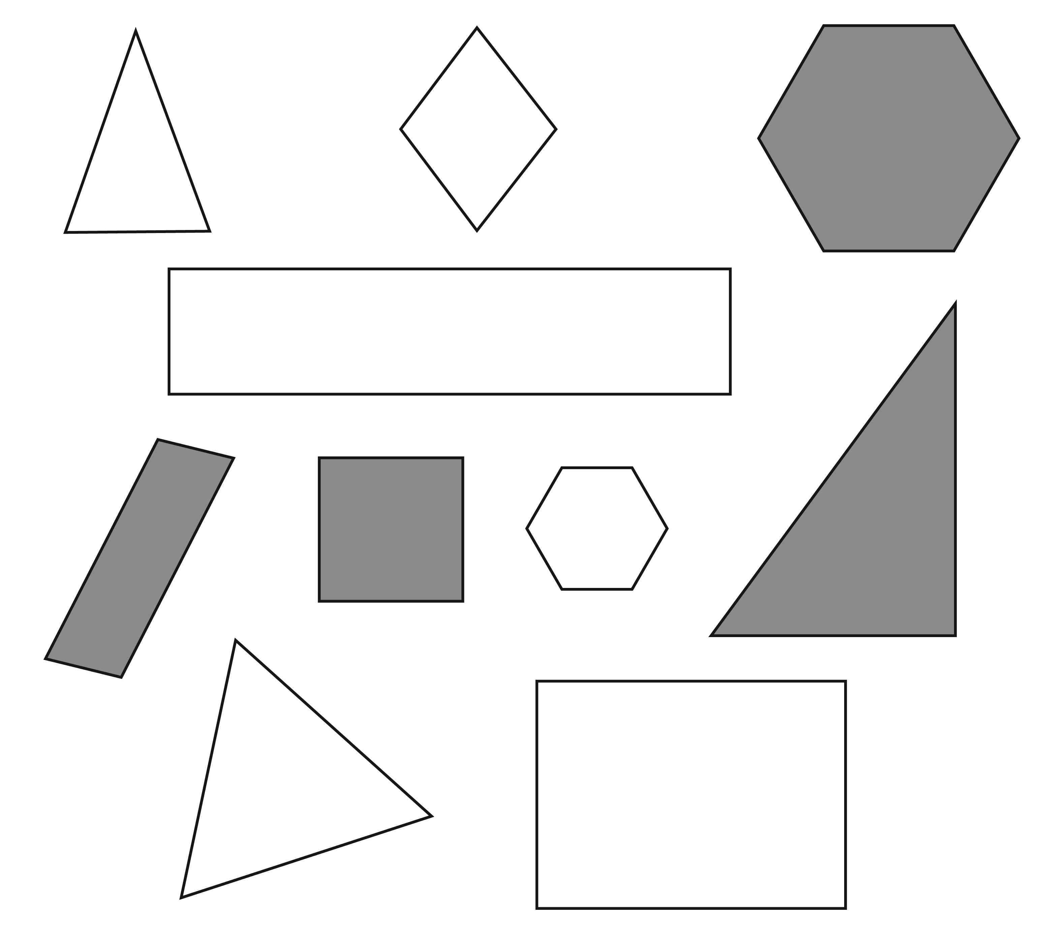

Explain how you know that the shapes you circled are quadrilaterals.

G Task 1b
Domain | Geometry
Cluster | Reason with shapes and their attributes.
Standard(s) | 2.G.1 Recognize and draw shapes having specified attributes, such as a given number of angles or a given number of equal faces. Identify triangles quadrilaterals, pentagons, hexagons, and cubes.  *Sizes are compared directly or visually, not compared by measuring.
Materials | SF, red, green, blue and orange crayon
Task | Provide the student with the materials. Say to the student:  - Use your red crayon to draw a circle around all of the pentagons.  - Use your green crayon to draw a circle around all of the triangles.  - Use your blue crayon to draw a circle around all of the hexagons.  - Use your orange crayon to draw a circle around all of the rectangles.

Continuum of Understanding
Developing Understanding | - Identifies some of the shapes correctly, but not all. | Correctly identifies all of the:  - pentagons  - triangles  - hexagons  - rectangles
Complete Understanding | - Correctly identifies all of the shapes.

Standards for Mathematical Practice
1. Makes sense and perseveres in solving problems.
2. Reasons abstractly and quantitatively.
3. Constructs viable arguments and critiques the reasoning of others.
4. Models with mathematics.
5. Uses appropriate tools strategically.
6. Attends to precision.
7. Looks for and makes use of structure.
8. Looks for and expresses regularity in repeated reasoning.

G Task 1b
ANSWER KEY
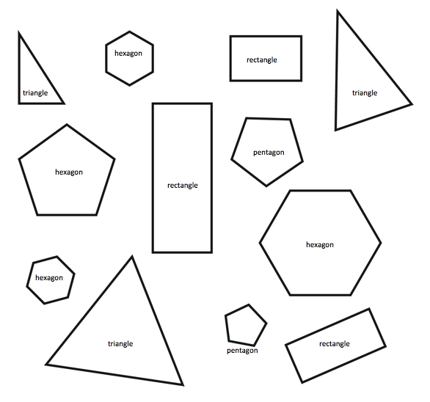
1. Use your red crayon to draw a circle around all of the pentagons.
2. Use your green crayon to draw a circle around all of the triangles.
3. Use your blue crayon to draw a circle around all of the hexagons.
4. Use your orange crayon to draw a circle around all of the rectangles.
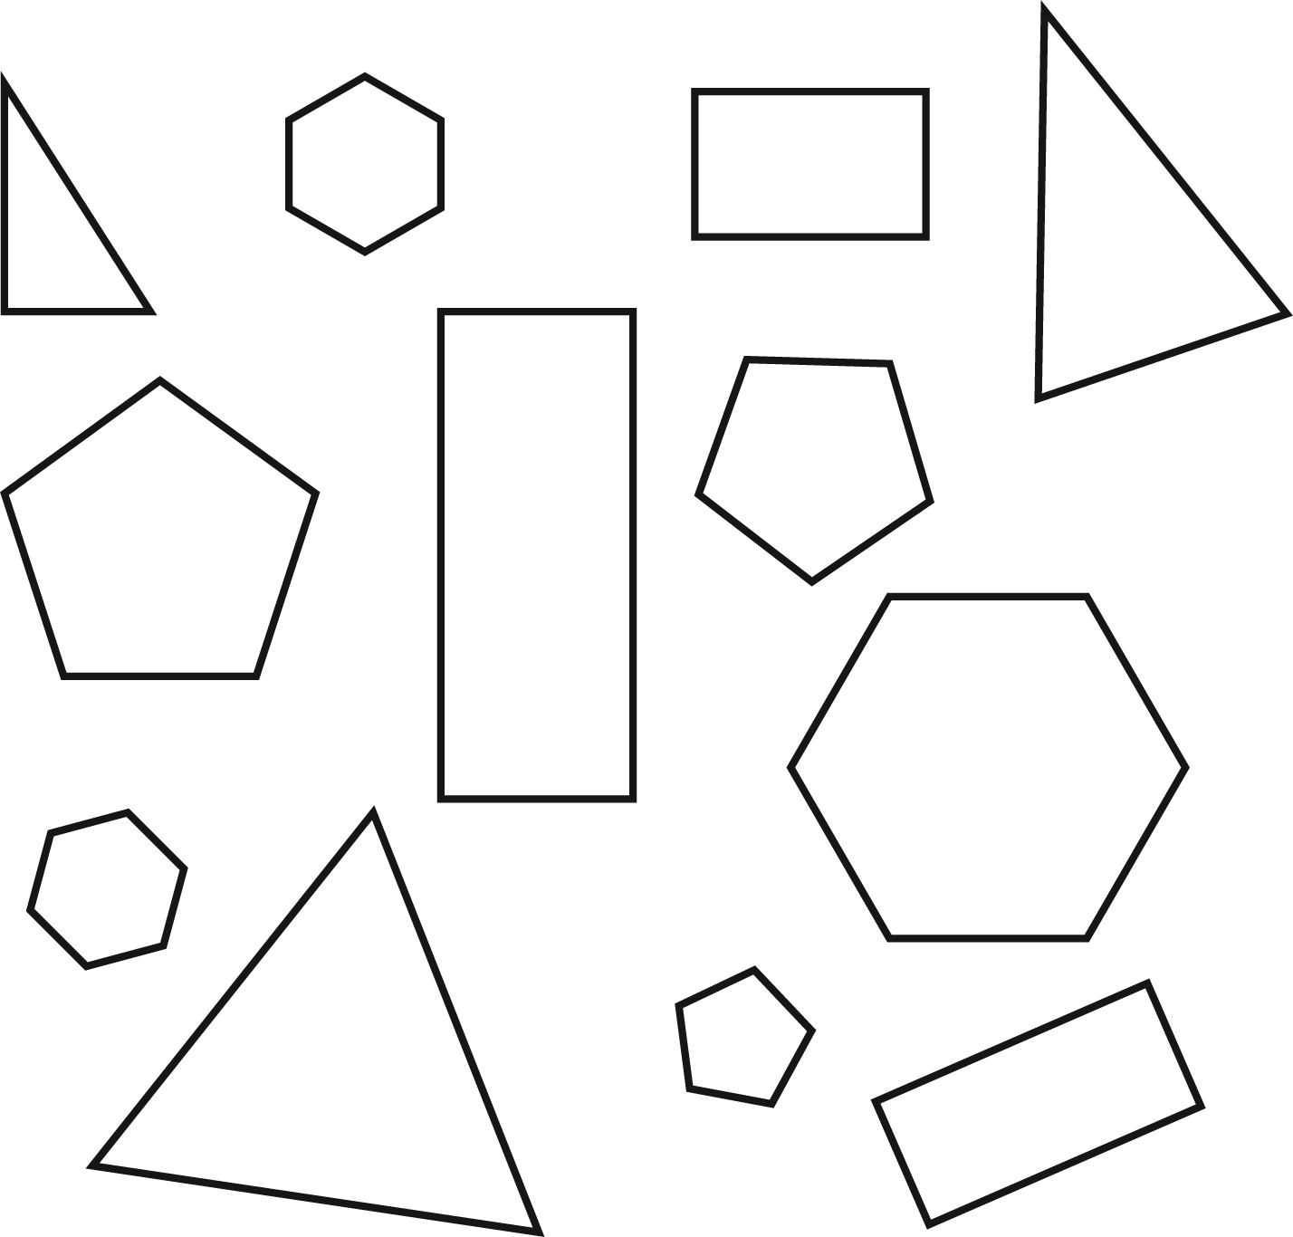

G Task 1c
Domain | Geometry
Cluster | Reason with shapes and their attributes.
Standard(s) | 2.G.1 Recognize and draw shapes having specified attributes, such as a given number of angles or a given number of equal faces. Identify triangles quadrilaterals, pentagons, hexagons, and cubes.  *Sizes are compared directly or visually, not compared by measuring.
Materials | Cube
Task | Show the student a cube. Ask: Is this shape a cube? Then, say: Why do you think it is (or isn’t) a cube? Students may tell or write their responses.

Continuum of Understanding
Developing Understanding | - States that the shape is not a cube.  - Identifies the shape as a cube, but does not use correct defining attributes to describe the shape.
Complete Understanding | - Correctly identifies the shape as a cube and uses defining attributes to describe the shape (e.g., 6 square faces)

Standards for Mathematical Practice
1. Makes sense and perseveres in solving problems.
2. Reasons abstractly and quantitatively.
3. Constructs viable arguments and critiques the reasoning of others.
4. Models with mathematics.
5. Uses appropriate tools strategically.
6. Attends to precision.
7. Looks for and makes use of structure.
8. Looks for and expresses regularity in repeated reasoning.

G Task 2a
Domain | Geometry
Cluster | Reason with shapes and their attributes.
Standard(s) | 2.G.2 Partition a rectangle into rows and columns of same-size squares and count to find the total number of them.
Materials | SF, pencil
Task | Provide the materials to the student. Read the directions: Partition the rectangle into 2 rows and 2 columns of same-size squares. How many squares do you have?

Continuum of Understanding
Developing Understanding | - Incorrectly partitioned the rectangle into 2 rows.  - Incorrectly partitioned the rectangle into 2 columns.  - Some of the squares were distinctly larger (or smaller) than others.  - Incorrectly counted the number of squares.
Complete Understanding | - Correctly partitioned the rectangle into 2 rows and 2 columns.  - The squares were approximately all the same size.  - Correctly counted 4 squares.

Standards for Mathematical Practice
1. Makes sense and perseveres in solving problems.
2. Reasons abstractly and quantitatively.
3. Constructs viable arguments and critiques the reasoning of others.
4. Models with mathematics.
5. Uses appropriate tools strategically.
6. Attends to precision.
7. Looks for and makes use of structure.
8. Looks for and expresses regularity in repeated reasoning.

Partition the rectangle into 2 rows and 2 columns of same-size squares.

How many same-size squares do you have? _____________________

G Task 2b
Domain | Geometry
Cluster | Reason with shapes and their attributes.
Standard(s) | 2.G.2 Partition a rectangle into rows and columns of same-size squares and count to find the total number of them.
Materials | SF, pencil
Task | Provide the materials to the student. Read the directions: Partition the rectangle into 3 rows and 4 columns of same-size squares. How many squares do you have?

Continuum of Understanding
Developing Understanding | - Incorrectly partitioned the rectangle into 3 rows.  - Incorrectly partitioned the rectangle into 4 columns.  - Some of the squares were distinctly larger (or smaller) than others.  - Incorrectly counted the number of squares.
Complete Understanding | - Correctly partitioned the rectangle into 3 rows and 4 columns.  - The squares were approximately all the same size.  - Correctly counted 12 squares.

Standards for Mathematical Practice
1. Makes sense and perseveres in solving problems.
2. Reasons abstractly and quantitatively.
3. Constructs viable arguments and critiques the reasoning of others.
4. Models with mathematics.
5. Uses appropriate tools strategically.
6. Attends to precision.
7. Looks for and makes use of structure.
8. Looks for and expresses regularity in repeated reasoning.

Partition the rectangle into 3 rows and 4 columns of same-size squares.
How many squares do you have?

How many same size squares do you have? _____________________

G Task 3a
Domain | Geometry
Cluster | Reason with shapes and their attributes.
Standard(s) | 2.G.3. Partition circles and rectangles into two, three, or four equal shares, describe the shares using the words halves, thirds, half of, a third of, etc., and describe the whole as two halves, three thirds, four fourths. Recognize that equal shares of identical wholes need not have the same shape.
Materials | SF, Paper, pencil
Task | Provide materials to the student. Read the problem: You have 3 rectangular cakes. Cut each cake into fourths in three different ways. Explain how you know that each cake has been partitioned into fourths.

Continuum of Understanding
Developing Understanding | - Incorrectly partitioned one or more cakes into 4 equal pieces.  - Explanation does not include an understanding that each cake needed to be partitioned into 4 pieces.  - Explanation does not include an understanding that each fractional part needs to be the same size. | Possible Solutions  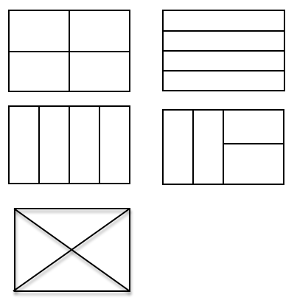  Note: Although each fractional piece may not be the same shape, the size (area) of each fractional piece has the same area. Each piece represents one-fourth of the whole rectangle.
Complete Understanding | - Correctly partitioned each rectangle into fourths in a different way.  - Explanation includes an understanding that there needs to be four pieces and that each fractional piece needs to be the same size.

Standards for Mathematical Practice
1. Makes sense and perseveres in solving problems.
2. Reasons abstractly and quantitatively.
3. Constructs viable arguments and critiques the reasoning of others.
4. Models with mathematics.
5. Uses appropriate tools strategically.
6. Attends to precision.
7. Looks for and makes use of structure.
8. Looks for and expresses regularity in repeated reasoning.

You have 3 rectangular cakes.

Cut each cake into fourths in three different ways.

Explain how you know that each cake has been partitioned into fourths.

G Task 3b
Domain | Geometry
Cluster | Reason with shapes and their attributes
Standard(s) | 2.G.3. Partition circles and rectangles into two, three, or four equal shares, describe the shares using the words halves, thirds, half of, a third of, etc., and describe the whole as two halves, three thirds, four fourths. Recognize that equal shares of identical wholes need not have the same shape.
Materials | SF, paper, pencil
Task | Provide materials to the student. Read the problem: You have 2 round cookies. Cut each cookie into fourths in two different ways. Explain how you know that each cookie has been partitioned into fourths.

Continuum of Understanding
Developing Understanding | - Incorrectly partitioned one or more cookies into 4 equal pieces.  - Explanation did not include an understanding that each cookie needed to be partitioned into 4 pieces.  - Explanation did not include an understanding that each fractional part needs to be the same size. | Possible Solutions  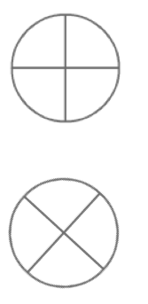
Complete Understanding | - Correctly partitioned each cookie into fourths in a different way.  - Explanation includes an understanding that there needs to be four pieces and that each fractional piece needs to be the same size.

Standards for Mathematical Practice
1. Makes sense and perseveres in solving problems.
2. Reasons abstractly and quantitatively.
3. Constructs viable arguments and critiques the reasoning of others.
4. Models with mathematics.
5. Uses appropriate tools strategically.
6. Attends to precision.
7. Looks for and makes use of structure.
8. Looks for and expresses regularity in repeated reasoning.

You have 2 round cookies.

Cut each cookie into fourths in two different ways.

Explain how you know that each cookie has been partitioned into fourths.

G Task 3c
Domain | Geometry
Cluster | Reason with shapes and their attributes.
Standard(s) | 2.G.3 Partition circles and rectangles into two, three, or four equal shares, describe the shares using the words halves, thirds, half of, a third of, etc., and describe the whole as two halves, three thirds, four fourths. Recognize that equal shares of identical wholes need not have the same shape.
Materials | SF, Paper, pencil
Task | Provide materials to the student. Read the problem to the student: Some students partitioned a rectangular cake in different ways. Look at each cake. Is each cake partitioned into fourths? Explain your reasoning.

Continuum of Understanding
Developing Understanding | - Incorrectly circles one or more cakes that are not partitioned into fourths.  - Circles some cakes that are partitioned into fourths, but not all.  - Justification does not include an understanding that each cake needed to be partitioned into 4 pieces.  - Explanation did not include an understanding that each fractional part needs to be the same size. | Solution:  Note: Although each fractional piece may not be the same shape, the size (area) of each fractional piece has the same area. Each piece represents one-fourth of the whole rectangular cake.
Complete Understanding | - Correctly circles all cakes correctly partitioned into fourths.  - Explanation includes an understanding that there needs to be four pieces and that each fractional piece needs to be the same size.

Standards for Mathematical Practice
1. Makes sense and perseveres in solving problems.
2. Reasons abstractly and quantitatively.
3. Constructs viable arguments and critiques the reasoning of others.
4. Models with mathematics.
5. Uses appropriate tools strategically.
6. Attends to precision.
7. Looks for and makes use of structure.
8. Looks for and expresses regularity in repeated reasoning.

Some students partitioned a rectangular cake in different ways.

Circle each cake that is correctly partitioned into fourths.

Explain your reasoning.

G Task 3d
Domain | Geometry
Cluster | Reason with shapes and their attributes.
Standard(s) | 2.G.3 Partition circles and rectangles into two, three, or four equal shares, describe the shares using the words halves, thirds, half of, a third of, etc., and describe the whole as two halves, three thirds, four fourths. Recognize that equal shares of identical wholes need not have the same shape.
Materials | BLM, pencil, scissors. The shapes may be cut out of the Blackline Master before providing shapes to the student.
Task | Provide the materials to the student. Read the problem to the student: Fold and cut the rectangle so that you can share it equally between 3 people. Explain how you know that you shared it equally between 3 people.  After the student has finished the rectangle task, say: Fold and cut the circle so that you can share it equally between 3 people. Explain how you know that you shared it equally between 3 people.

Continuum of Understanding
Developing Understanding | - Incorrectly partitions one or both shapes into 3 equal pieces.  - Explanation does not include an understanding that each cake needed to be partitioned into 3 pieces.  - Explanation does not include an understanding that each fractional part needs to be the same size. | Strategy(ies):  - Folds and cuts shapes  - Draws lines before cutting  - Stacks shapes on top of each other to check size of each  - Other:
Complete Understanding | - Correctly partitioned both shapes into thirds.  - Explanation includes an understanding that there needs to be three pieces and that each fractional piece needs to be the same size.

Standards for Mathematical Practice
1. Makes sense and perseveres in solving problems.
2. Reasons abstractly and quantitatively.
3. Constructs viable arguments and critiques the reasoning of others.
4. Models with mathematics.
5. Uses appropriate tools strategically.
6. Attends to precision.
7. Looks for and makes use of structure.
8. Looks for and expresses regularity in repeated reasoning.

