MD Task 1a
Domain | Measurement and Data
Cluster | Measure lengths indirectly and by iterating length units.
Standard(s) | 1.MD.1 Order three objects by length.
Materials | 3 connecting cube trains of all the same color: Train 1: 8 cubes snapped together; Train 2: 4 cubes snapped together; Train 3: 4 cubes snapped together
Task | Place the 3 trains on the table. Ask: What do you notice about these trains? Prompt if needed, What is different about the trains? Say: Put these trains in order by length. Prompt if needed: Put them in order from shortest to longest.

Continuum of Understanding
Developing Understanding | - Does not use comparison language (longer, shorter) when describing the trains, even after a prompt.  - Attempts to put the trains in order (either from shortest to longest or longest to shortest) but does so incorrectly, regardless of the prompt.
Complete Understanding | - Uses comparison language to describe the differences between the trains.  - Puts the trains in order (either from shortest to longest or longest to shortest) with or without prompts.

Standards for Mathematical Practice
1. Makes sense and perseveres in solving problems.
2. Reasons abstractly and quantitatively.
3. Constructs viable arguments and critiques the reasoning of others.
4. Models with mathematics.
5. Uses appropriate tools strategically.
6. Attends to precision.
7. Looks for and makes use of structure.
8. Looks for and expresses regularity in repeated reasoning.

MD Task 1b
Domain | Measurement and Data
Cluster | Measure lengths indirectly and by iterating length units.
Standard(s) | 1.MD.1 Compare the lengths of two objects indirectly by using a third object.
Materials | BLM of cat and dog paths, string cut to 3 inches
Task | Provide materials to the student. Read the problem to the student: The cat walks along the path to the bowl of milk. The dog walks along the path to the park. Which animal walks the longest path? Use the string to help you decide.

Continuum of Understanding
Developing Understanding | - Uses fingers or visually compares the two paths to determine which is longer.  - Attempted to use the string to compare to two paths, but was unable to determine the longest.
Complete Understanding | - Accurately used a third object (the string) to compare the lengths of the two paths.

Standards for Mathematical Practice
1. Makes sense and perseveres in solving problems.
2. Reasons abstractly and quantitatively.
3. Constructs viable arguments and critiques the reasoning of others.
4. Models with mathematics.
5. Uses appropriate tools strategically.
6. Attends to precision.
7. Looks for and makes use of structure.
8. Looks for and expresses regularity in repeated reasoning.

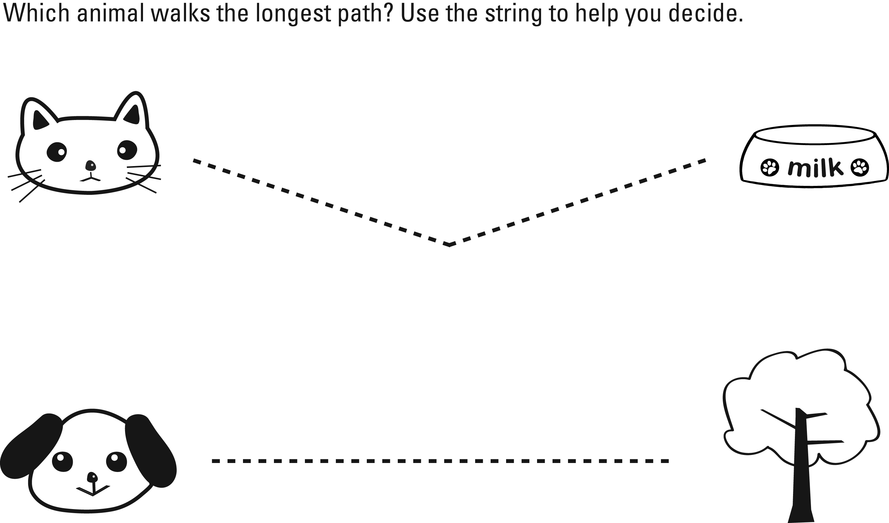

MD Task 1c
Domain | Measurement and Data
Cluster | Measure lengths indirectly and by iterating length units.
Standard(s) | 1.MD.1 Compare the lengths of two objects indirectly by using a third object.
Materials | Identify 2 items in the classroom that are similar in length/height, but not exactly the same (e.g., door frame and a table; edge of a carpet and window sill), string measuring 8 inches in length
Task | Tell the student that s/he needs to determine which of the two items is longer- point to the two items in the classroom using the string. Ask the student to use the string to figure out which of the two items is longest.

Continuum of Understanding
Developing Understanding | - Attempts to use the string to measure, but is unsuccessful.  - Incorrectly identifies the longest item.
Complete Understanding | - Uses the string to compare the lengths of two objects.  - Correctly identifies the longest item.

Standards for Mathematical Practice
1. Makes sense and perseveres in solving problems.
2. Reasons abstractly and quantitatively.
3. Constructs viable arguments and critiques the reasoning of others.
4. Models with mathematics.
5. Uses appropriate tools strategically.
6. Attends to precision.
7. Looks for and makes use of structure.
8. Looks for and expresses regularity in repeated reasoning.

MD Task 2a
Domain | Measurement and Data
Cluster | Measure lengths indirectly and by iterating length units.
Standard(s) | 1.MD.1 Order three objects by length.  1.MD.2 Express the length of an object as a whole number of length units, by laying multiple copies of a shorter object (the length unit) end to end; understand that the length measurement of an object is the number of same-size length units that span it with no gaps or overlaps. Limit to contexts where the object being measured is spanned by a whole number of length units with no gaps or overlaps.
Materials | BLM of rectangles of various lengths; 15 small paperclips of the same size that measure each rectangle in whole units without any overlaps or gaps
Task | Provide the student 15 small paperclips. Walk the student through the various steps of the task: Say:  Use paperclips to measure the length of each rectangle.  Write the number of paperclips you used for each rectangle.  Circle the shortest rectangle. Put a box around the longest rectangle.  Order the rectangles from shortest to longest. Use #1 for the shortest rectangle, # 2 for the middle rectangle and #3 for the longest.

Continuum of Understanding
Developing Understanding | - Attempts to use paperclips to measure the rectangles, but has gaps and/or overlaps when measuring.  - Counts the number of paperclips used incorrectly.  - Incorrectly determines which rectangle is the shortest/longest.  - Correctly locates the shortest and/or longest, but incorrectly orders the rectangles from shortest to longest.
Complete Understanding | - Accurately measures each rectangle without any gaps or overlaps.  - Correctly identifies the longest and shortest rectangle.  - Orders the three rectangles by length.

Standards for Mathematical Practice
1. Makes sense and perseveres in solving problems.
2. Reasons abstractly and quantitatively.
3. Constructs viable arguments and critiques the reasoning of others.
4. Models with mathematics.
5. Uses appropriate tools strategically.
6. Attends to precision.
7. Looks for and makes use of structure.
8. Looks for and expresses regularity in repeated reasoning.

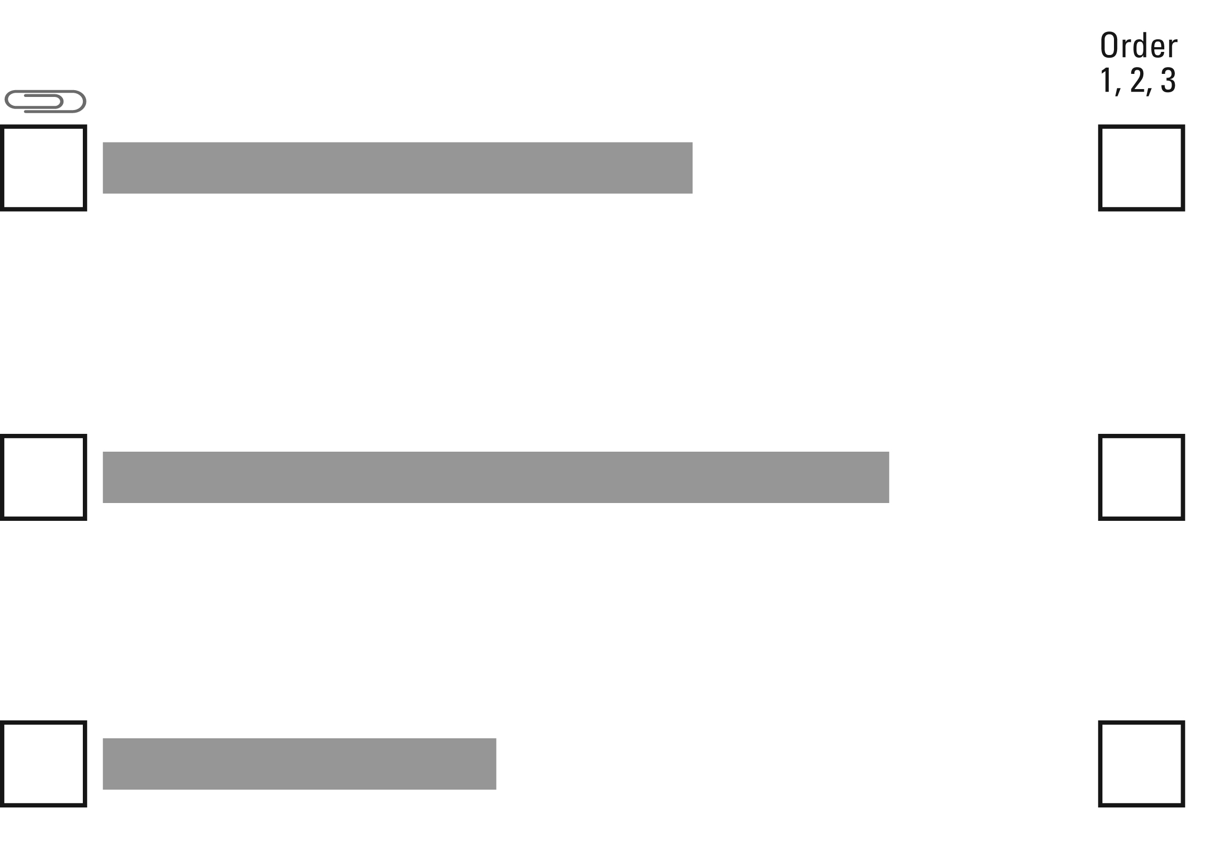
Use paperclips to measure the length of each rectangle. Write the number of paperclips you used for each rectangle. Circle the shortest rectangle. Put a box around the longest rectangle. Order the rectangles from shortest to longest.

MD Task 2b
Domain | Measurement and Data
Cluster | Measure lengths indirectly and by iterating length units.
Standard(s) | 1.MD.2 Express the length of an object as a whole number of length units, by laying multiple copies of a short object end to end; understand that the length measurement of an object is the number of same-size length units that span it with no gaps or overlaps.
Materials | SF of line measured incorrectly by paperclips, pencil
Task | Provide materials to the student. Read the problem to the student: Joe measured the length of the line using paper clips. He told his teacher that it was 8 paperclips long. Do you think Joe is correct? Why? Why Not? Show your thinking with pictures, numbers, or words.

Continuum of Understanding
Developing Understanding | - Counts 8 paperclips and states that Joe is correct.  - Does not notice that the paperclips are overlapping and have gaps.
Complete Understanding | - Correctly identifies that Joe measured the length of the line incorrectly.  - States the importance of carefully measuring an object without any overlaps or gaps.

Standards for Mathematical Practice
1. Makes sense and perseveres in solving problems.
2. Reasons abstractly and quantitatively.
3. Constructs viable arguments and critiques the reasoning of others.
4. Models with mathematics.
5. Uses appropriate tools strategically.
6. Attends to precision.
7. Looks for and makes use of structure.
8. Looks for and expresses regularity in repeated reasoning.

Joe measured the length of the line using paper clips. He told his teacher that it was 8 paperclips long.
Do you think Joe is correct? Show your thinking with pictures, numbers, or words.

MD Task 3a
Domain | Measurement and Data
Cluster | Tell and write time.
Standard(s) | 1.MD.3 Tell and write time in hours and half-hours using analog and digital clocks.
Materials | SF of clocks
Task | Provide the student with the student form. Say: What time is it? Write the time next to the clock.  Then say: Look at the digital clock. Draw the hands on the clock to show the same time.

Continuum of Understanding
Developing Understanding | - Inconsistently reads and/or write the time. | - Tells time to the hour.  - Writes time to the hour.  - Tells time to the half hour.  - Writes time to the half hour.
Complete Understanding | - Reads and writes time in hours and half hours.

Standards for Mathematical Practice
1. Makes sense and perseveres in solving problems.
2. Reasons abstractly and quantitatively.
3. Constructs viable arguments and critiques the reasoning of others.
4. Models with mathematics.
5. Uses appropriate tools strategically.
6. Attends to precision.
7. Looks for and makes use of structure.
8. Looks for and expresses regularity in repeated reasoning.

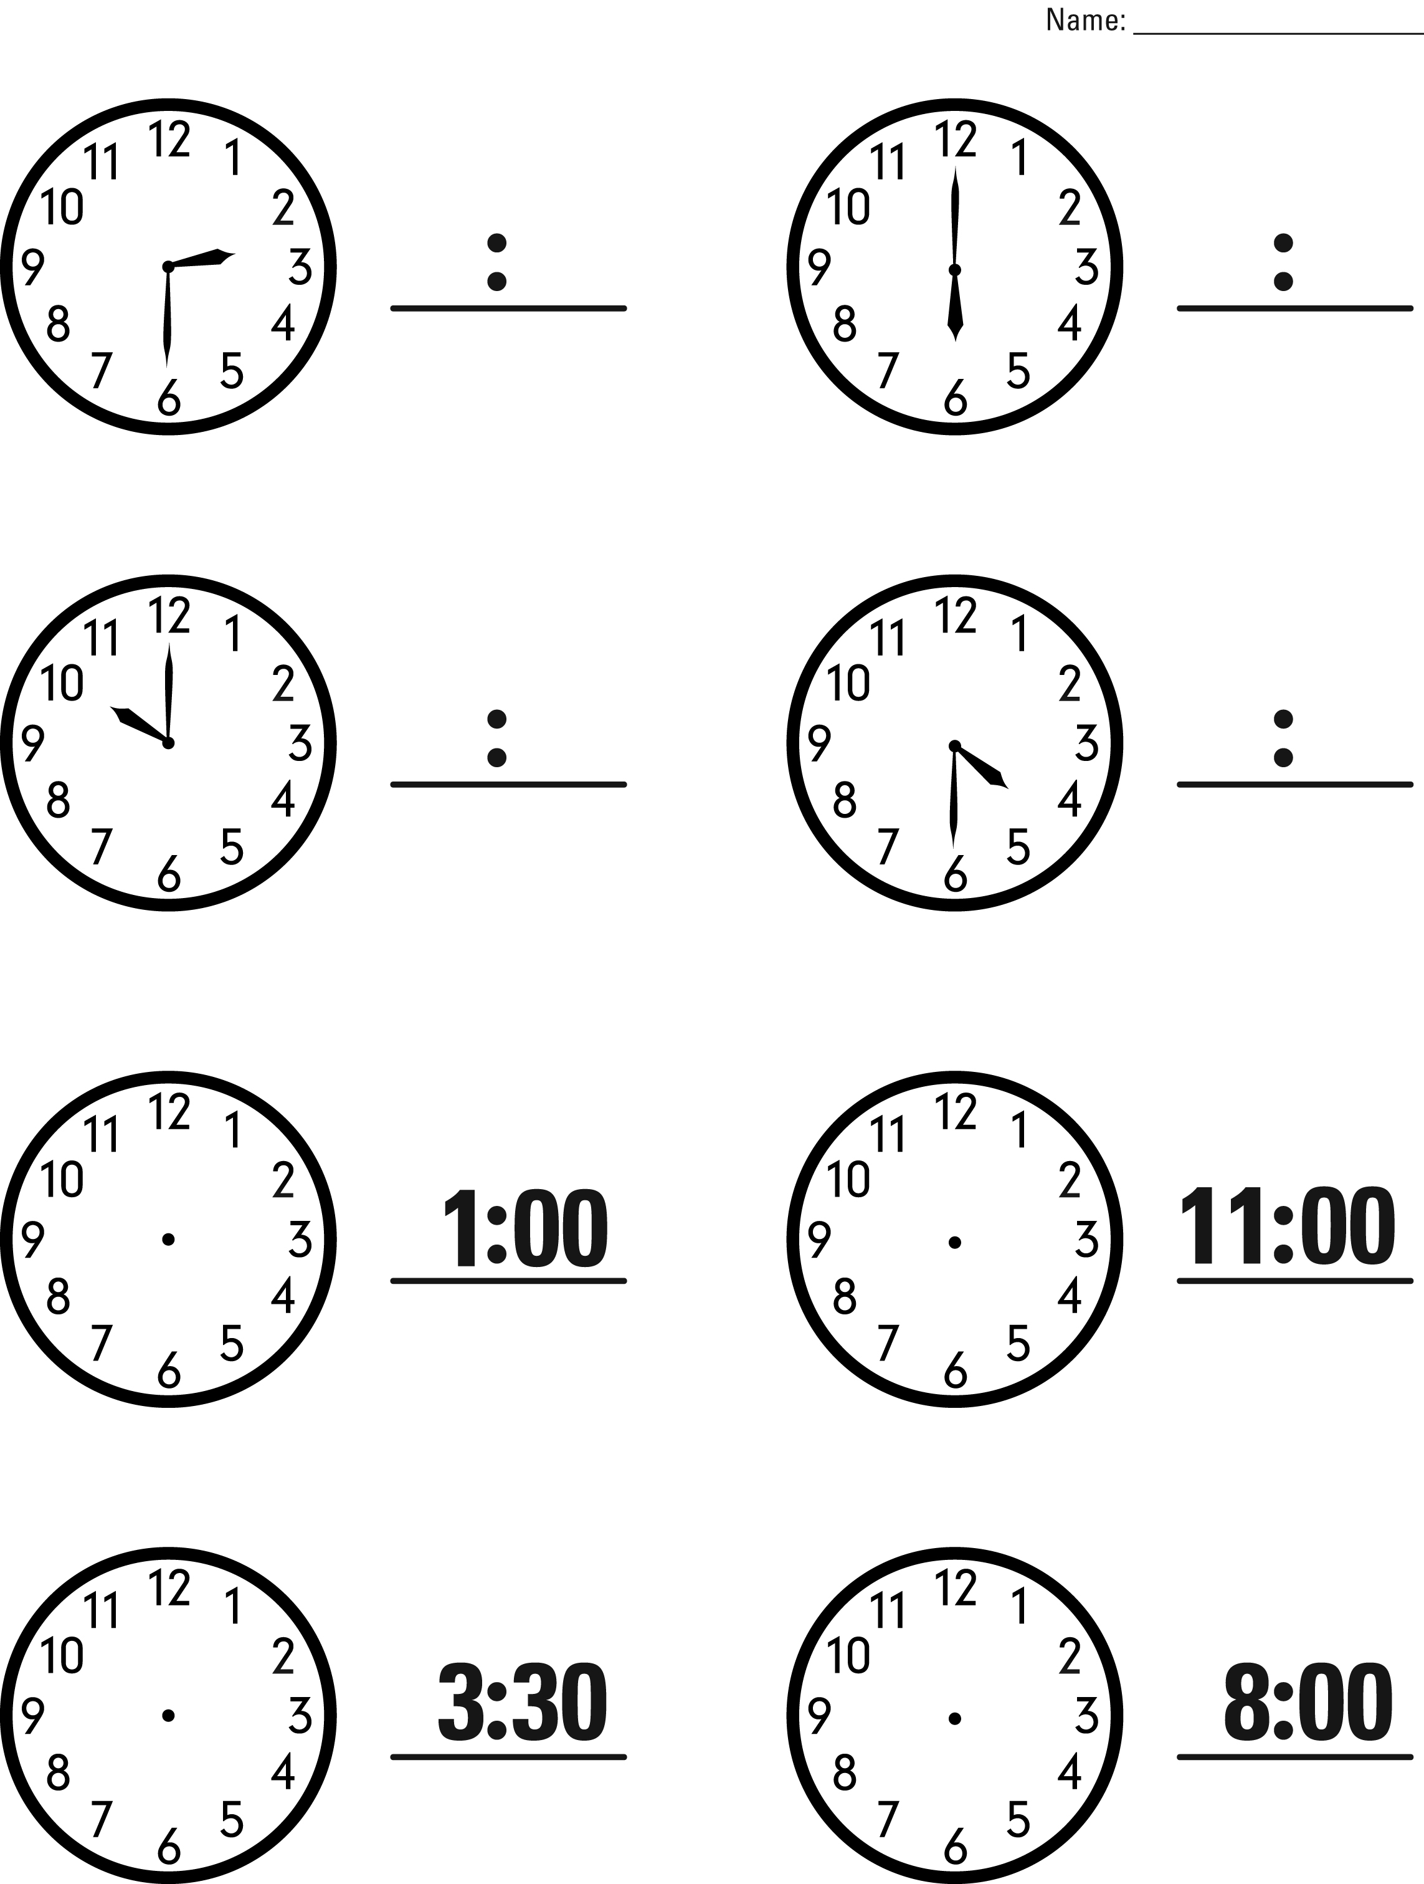

MD Task 4a
Domain | Measurement and Data
Cluster | Represent and interpret data
Standard(s) | 1.MD.4 Organize, represent, and interpret data with up to three categories; ask and answer questions about the total number of data points, how many in each category, and how many more or less are in one category than in another.
Materials | BLM First Graders’ Favorite Colors
Task | Show the student BLM. Say: Look at the data about First Graders’ Favorite Colors. What does the data tell you about their favorite colors? Prompt, if needed: What else does the data tell you?

Continuum of Understanding
Developing Understanding | - The explanation is minimal or lacking in detail. It may only include the amount of students who like one particular color or only includes one comparison.
Complete Understanding | - Provides a detailed description about the amount of students who like each color.  - Compares multiple categories (Ex: Blue is the favorite color. Green is the least favorite.)
Advanced Understanding | Demonstrates Complete Understanding and:  - Makes comparisons by stating “how many more/less” one category compares to another.  - Identified that there were 23 students who answered the survey.

Standards for Mathematical Practice
1. Makes sense and perseveres in solving problems.
2. Reasons abstractly and quantitatively.
3. Constructs viable arguments and critiques the reasoning of others.
4. Models with mathematics.
5. Uses appropriate tools strategically.
6. Attends to precision.
7. Looks for and makes use of structure.
8. Looks for and expresses regularity in repeated reasoning.

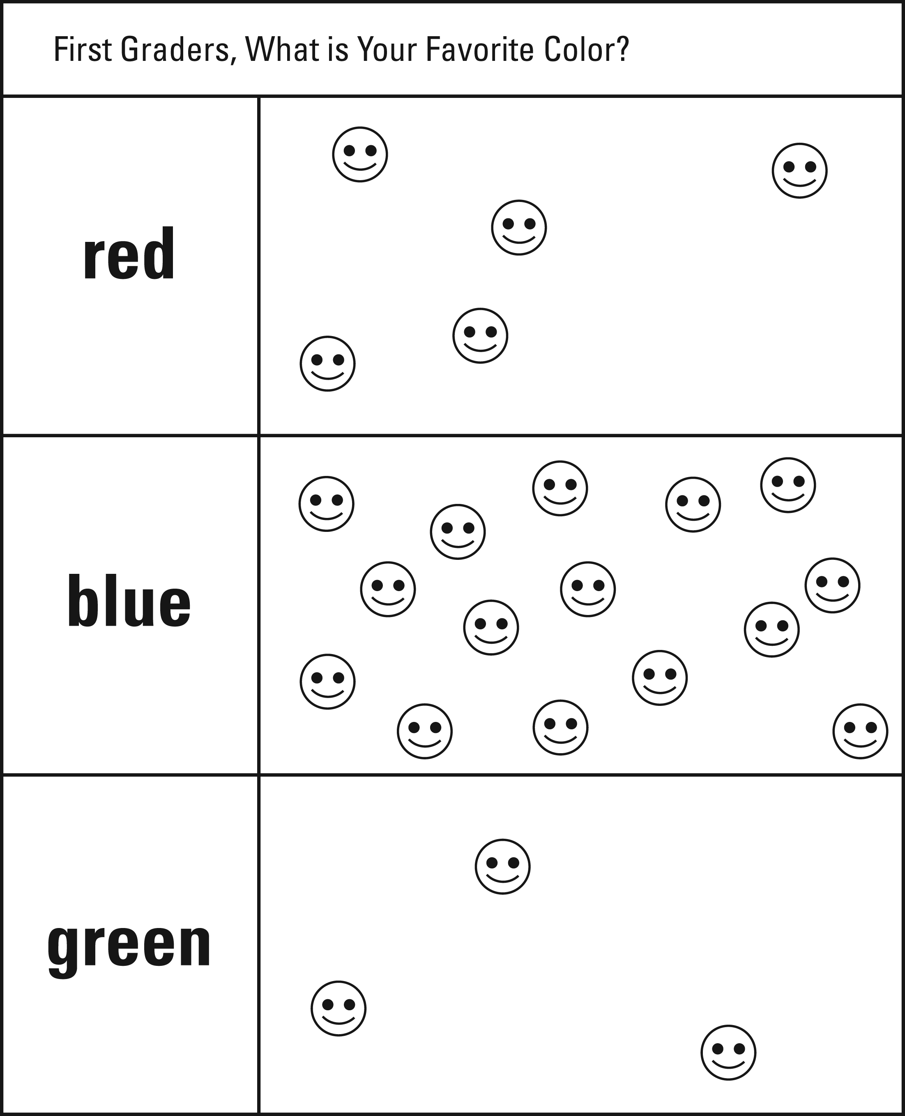
What is your Favorite Color?

MD Task 4b
Domain | Measurement and Data
Cluster | Represent and interpret data
Standard(s) | 1.MD.4 Organize, represent, and interpret data with up to three categories; ask and answer questions about the total number of data points, how many in each category, and how many more or less are in one category than in another.
Materials | BLM of animals cut into cards
Task | Cut out the animal cards and mix them up. Show the student the animal cards. Say: How could you organize the cards into groups? After the student responds, say: Put the cards into groups. Once the cards are sorted, ask the student:  - Compare your groups. What do you notice about each of your groups? Prompt if needed: Is there anything that is the same about your categories? Different?  - Then ask: How many more cats are there than dogs? How many more dogs would you need to have the same amount as birds?

Continuum of Understanding
Developing Understanding | - Identifies a way to organize the cards, but inconsistently sorts as indicated.  - Changes the category(ies) during the organization process.  - Sorts the cards but does not compare the groups, even after prompting.  - Solves one or more “how many more” questions incorrectly. | - Sorts and classifies cards into categories.  - Identifies “most”  - Identifies “least”.  - Correctly solves “how many more” questions.
Complete Understanding | - Identifies a way to organizes the cards and sorts them correctly and as indicated.  - Compares the groups accurately, identifying such features as most, least, same.  - Solves all “how many more” questions correctly.

Standards for Mathematical Practice
1. Makes sense and perseveres in solving problems.
2. Reasons abstractly and quantitatively.
3. Constructs viable arguments and critiques the reasoning of others.
4. Models with mathematics.
5. Uses appropriate tools strategically.
6. Attends to precision.
7. Looks for and makes use of structure.
8. Looks for and expresses regularity in repeated reasoning.

