G Task 1a
Domain | Geometry
Cluster | Reason with shapes and their attributes.
Standard(s) | 1.G.1 Distinguish between defining attributes (e.g., triangles are closed and three-sided) versus non-defining attributes (e.g., color, orientation, overall size); build and draw shapes to possess defining attributes.
Materials | SF, pencil
Task | Show the student BLM with the various shapes. Ask the student to circle all of the triangles. Once the student has finished circling shapes, ask: “How did you know that those shapes were triangles?” Then, pointing to a shape that looks similar to a triangle, ask: “You did not pick this shape. Why is this shape not a triangle?”

Continuum of Understanding
Developing Understanding | - Identifies some of the triangles correctly, but not all.  - Uses non-defining attributes to justify selection. | Correctly identifies defining attributes of triangles:  - closed figure  - 3 sides  - 3 angles
Complete Understanding | - Identifies all of the triangles correctly.  - Uses defining attributes to justify selection.

Standards for Mathematical Practice
1. Makes sense and perseveres in solving problems.
2. Reasons abstractly and quantitatively.
3. Constructs viable arguments and critiques the reasoning of others.
4. Models with mathematics.
5. Uses appropriate tools strategically.
6. Attends to precision.
7. Looks for and makes use of structure.
8. Looks for and expresses regularity in repeated reasoning.

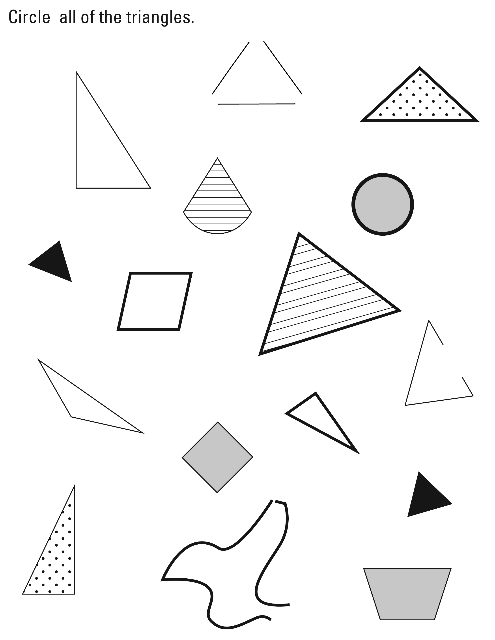

G Task 1b
Domain | Geometry
Cluster | Reason with shapes and their attributes.
Standard(s) | 1.G.1 Distinguish between defining attributes (e.g., triangles are closed and three-sided) versus non-defining attributes (e.g., color, orientation, overall size); build and draw shapes to possess defining attributes.
Materials | BLM
Task | Show the student the square-like shapes. Ask: “Which one of these shapes is a square?” Then ask (regardless of if the student answered correctly): “How do you know that shape is a square?” Then, pointing to a shape that looks similar to a square, ask: “You did not pick this shape. Why is this shape not a square?”  Repeat with trapezoids and rectangles.

Continuum of Understanding
Developing Understanding | - Identifies some of the shapes correctly, but not all.  - Identifies the shapes but uses non-defining attributes to justify selection. | Correctly identifies shapes:  - rectangle  - square  - trapezoid
Complete Understanding | - Identifies all of the shapes correctly.  - Uses defining attributes to justify selection.

Standards for Mathematical Practice
1. Makes sense and perseveres in solving problems.
2. Reasons abstractly and quantitatively.
3. Constructs viable arguments and critiques the reasoning of others.
4. Models with mathematics.
5. Uses appropriate tools strategically.
6. Attends to precision.
7. Looks for and makes use of structure.
8. Looks for and expresses regularity in repeated reasoning.

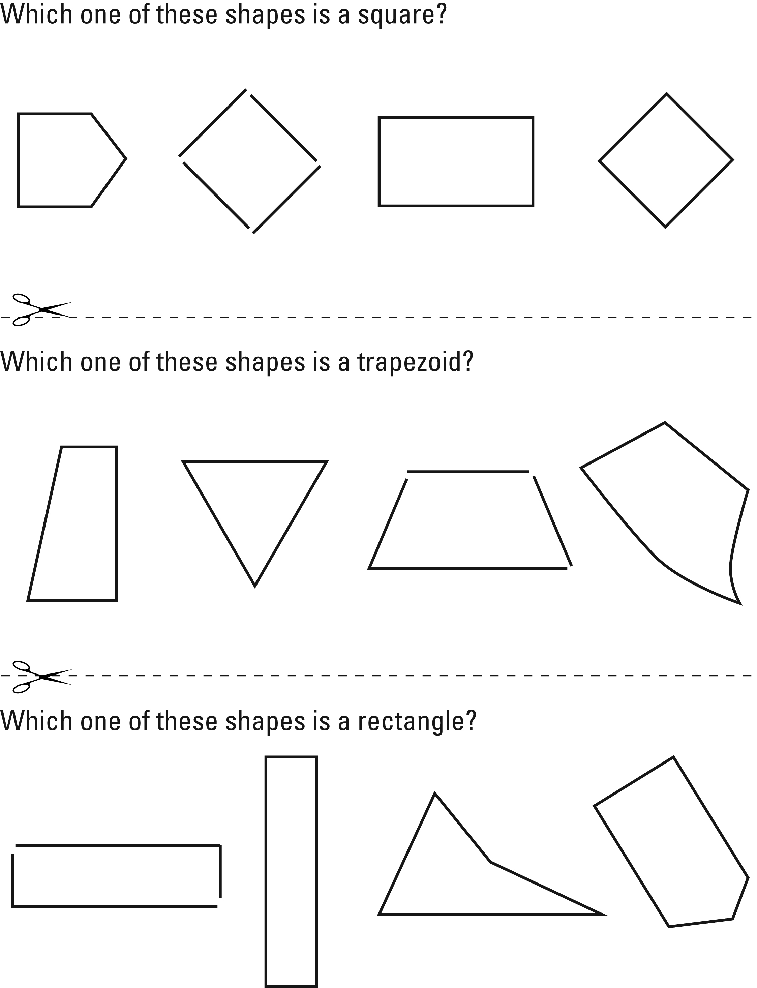

G Task 1c
Domain | Geometry
Cluster | Reason with shapes and their attributes.
Standard(s) | 1.G.1 Distinguish between defining attributes (e.g., triangles are closed and three-sided) versus non-defining attributes (e.g., color, orientation, overall size); build and draw shapes to possess defining attributes.
Materials | Handful of sticks (e.g., craft sticks, tooth picks, coffee stirrers)
Task | Provide a handful of sticks to the student. Say: “Use these sticks to make a square.” Once the student is finished, ask: “How do you know that your shape is a square?” Repeat with triangle, rectangle, and trapezoid.

Continuum of Understanding
Developing Understanding | - Builds some of the shapes accurately, but not all.  - Uses non-defining attributes when describing one or more shapes of the shapes. | Correctly builds shapes:  - triangle  - rectangle  - square  - trapezoid  Correctly describes shapes with defining attributes:  - triangle  - rectangle  - square  - trapezoid
Complete Understanding | - Builds each shape correctly.  - Uses defining attributes to describe each shape.

Standards for Mathematical Practice
1. Makes sense and perseveres in solving problems.
2. Reasons abstractly and quantitatively.
3. Constructs viable arguments and critiques the reasoning of others.
4. Models with mathematics.
5. Uses appropriate tools strategically.
6. Attends to precision.
7. Looks for and makes use of structure.
8. Looks for and expresses regularity in repeated reasoning.

G Task 2
Domain | Geometry
Cluster | Reason with shapes and their attributes.
Standard(s) | 1.G.2 Compose two-dimensional shapes (rectangles, squares, trapezoids, triangles, half-circles, and quarter-circles) or three- dimensional shapes (cubes, right rectangular prisms, right circular cones, and right circular cylinders) to create a composite shape, and compose new shapes from the composite shape. (Students do not need to learn formal names such as “right rectangular prism”)
Materials | BLM of two-dimensional shapes- cut apart, tape
Task | Cut apart the various shapes on the blackline master. Provide the student with a set of two-dimensional shapes. Say: I have a pile of different shapes. Choose two of them to put together to create a new shape. After the student creates the shape say: Describe your new shape.  Tape the two shapes together and slide the new composite shape to the side and ask the student to do them same thing with two of the remaining shapes. After the student creates the shape say: Describe your new shape. Tape the two shapes together.  Slide the first composite shape next to the new shape. Then say, You made two new shapes. Now, put them together to create a brand new shape.  After the student creates the shape say: Describe your new shape.

Continuum of Understanding
Developing Understanding | - Describes the new shapes using non-geometric attributes only (e.g., “It looks like a rocket.”).
Complete Understanding | - Creates a composite shape using two of the given shapes.  - Describes the new shapes using geometric attributes (e.g., number of sides, corners, length of sides)  - Creates a new composite shapes using the two shapes created.

Standards for Mathematical Practice
1. Makes sense and perseveres in solving problems.
2. Reasons abstractly and quantitatively.
3. Constructs viable arguments and critiques the reasoning of others.
4. Models with mathematics.
5. Uses appropriate tools strategically.
6. Attends to precision.
7. Looks for and makes use of structure.
8. Looks for and expresses regularity in repeated reasoning.

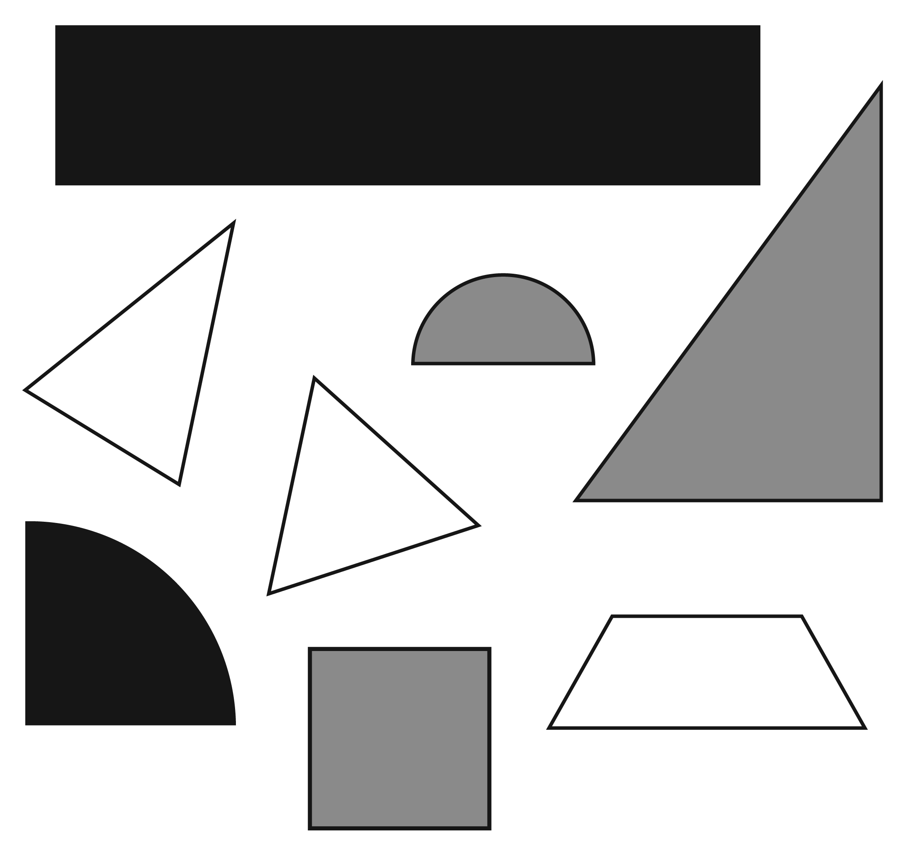

G Task 3a
Domain | Geometry
Cluster | Reason with shapes and their attributes.
Standard(s) | 1.G.3 Partition circles and rectangles into two and four equal shares, describe the shares using the words halves, fourths, and quarters, and use the phrases half of, fourth of, and quarter of. Describe the whole as two of, or four of the shares. Understand for these examples that decomposing into more equal shares creates smaller shares.
Materials | SF with circle and rectangle, crayon or pencil
Task | Provide the materials to the student. Read the problem to the student:  - Mario wants to cut the pizza into equal pieces and give his sister a fourth of the pizza to eat. Color the piece of pizza that Mario would give his sister.  - Christopher wants to give half of his candy bar to his brother. Color the piece of the candy bar that Christopher would give his brother.

Continuum of Understanding
Developing Understanding | - Partitions the pizza and/or the candy bar, but does not partition them into equal sized pieces.  - Partitions the pizza correctly, but incorrectly identifies one fourth.  - Partitions the candy bar correctly, but incorrectly identifies one half.
Complete Understanding | - Correctly partitions the pizza into four equal parts.  - Correctly colors one fourth of the pizza.  - Correctly partitions the rectangle into two equal shares.  - Correctly colors one half of the candy bar.

Standards for Mathematical Practice
1. Makes sense and perseveres in solving problems.
2. Reasons abstractly and quantitatively.
3. Constructs viable arguments and critiques the reasoning of others.
4. Models with mathematics.
5. Uses appropriate tools strategically.
6. Attends to precision.
7. Looks for and makes use of structure.
8. Looks for and expresses regularity in repeated reasoning.

Mario wants to cut the pizza into equal pieces and give his sister a fourth of the pizza to eat. Color the piece of pizza that Mario would give his sister.

Christopher wants to give half of his candy bar to his brother. Color the piece of the candy bar that Christopher would give his brother.

G Task 3b
Domain | Geometry
Cluster | Reason with shapes and their attributes.
Standard(s) | 1.G.3 Partition circles and rectangles into two and four equal shares, describe the shares using the words halves, fourths, and quarters, and use the phrases half of, fourth of, and quarter of. Describe the whole as two of, or four of the shares. Understand for these examples that decomposing into more equal shares creates smaller shares.
Materials | BLM of shapes partitioned, pencil
Task | Provide the materials to the student. Read the problem to the student: Circle all of the pictures that are correctly partitioned into fourths.  Point to a picture that the student did not circle and ask, Why did you decide not to circle this shape?

Continuum of Understanding
Developing Understanding | - Circles one or more pictures that are not partitioned into fourths.  - Explanation does not include an understanding that a picture needs to be partitioned into 4 pieces.  - Explanation does not include an understanding that each fractional part needs to be the same size.
Complete Understanding | - Correctly identifies all of the pictures that were partitioned into fourths.  - Explanation includes an understanding that there needs to be four pieces and that each fractional piece needs to be the same size.

Standards for Mathematical Practice
1. Makes sense and perseveres in solving problems.
2. Reasons abstractly and quantitatively.
3. Constructs viable arguments and critiques the reasoning of others.
4. Models with mathematics.
5. Uses appropriate tools strategically.
6. Attends to precision.
7. Looks for and makes use of structure.
8. Looks for and expresses regularity in repeated reasoning.

